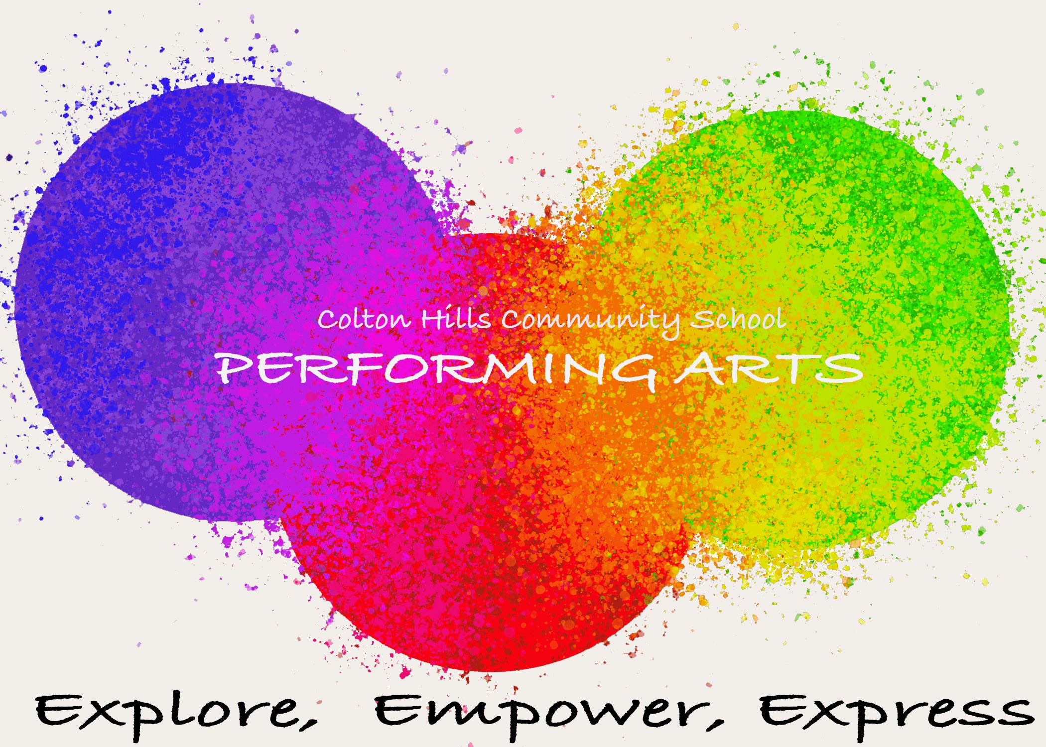

Drama

CURRICULUM PLAN

Department: Performing Arts (Drama, Dance and Music)

Vision Statement:

The arts are vital for engaging and maximising the life chances of all students by providing a stimulating, challenging and respectful environment. To develop artistically literate students who are able to fully engage with current issues and critically evaluate information.

Strapline:

Explore, Empower, Express (To explore, you will empower and creatively express)

Curriculum Story:

Students will explore the mythical and revolutionary of historical and modern texts, devising complex characters to empower and communicate a creative expression.

Skills developed:

To enable young performance artists to progress to the next stage of their career and provide them with the tools they need to succeed. Each performing arts lesson embeds literacy, applied numeracy and expand upon a transferable skill set.

Year 7: Mythical Madness
Experiment with the stylings of practitioners to conjure character and concepts.
Topics | Why we  teach this | Links to  last topic | Links to future topics | Key skills developed | Cultural capital opportunities | Links to whole school curriculum
Term 1 To explore two conflicting styles of theatre.
Harry Potter | Students will identify and examine the differences between Naturalism acting (Stanslavski) and Non-Naturalism (Physical Theatre). | Introduction to subject specific terminology. | To examine successful characterisation. | Development in subject specific knowledge.  Independent and group verbal and written articulation to assess the success of one’s own work. | Development of creative and imaginative language. | Exploration of character and story in English literature and language.
Term 2 To empower actors in delivering performances that can manipulate the mind of Macbeth.
Macbeth | Students will creatively explore a staple of the drama curriculum: Shakespeare as a genre of theatre and gain an understanding of the language. | Creatively consider the use of language and drama strategies to develop character. | To encourage empathy and emotional engagement towards a given character. | Analyse how to read subtext within Shakespearian language. Explore more complex characterisation skills through changes in body language and voice. | Explore the development of historical language and critique the impact to a modern day audience. | Exploration of context and protagonist in History and English.
Term 3 To express professional work through character developments
Lord of the Flies | Examine the impact character profiling can have on an actor’s performance whilst analysing the levels of tension within a script through applying LeCoq levels of tension principle. | Annotating a given script and selecting appropriate drama practises to support context and character. | Establishing and honing skills in creative leadership. | Discover the positive impact of workshopping a character outside of the script. | The context of the play will encourage students to develop an emotional intelligence | Exploration of theme in English, Life Skills and History.

Year 8: Radical Revolution
Examine the behaviours of theatre of different time periods.
Topics | Why we  teach this | Links to  last topic | Links to future topics | Key skills developed | Cultural capital opportunities | Links to whole school curriculum
Term 1 To explore the exaggerate style of Silent Movies.
Silent Movies | Exploration of a new genre of acting and how to devise using slapstick comedy with detail of historical context of 1920 performance style. | Application of dramatic strategies. | Manipulating the given dramatic strategies to encourage differing audience responses. | Students will embody the skills for successful and effective improvisation including hot seating. | Students will analyse the stylistics of professionals and the expectations of the given genre. | Exploration of genre in English and Art.
Term 2 To empower students to chaotically lose control like The Tempest storm.
The Tempest | Students will creatively explore Shakespeare as a genre of theatre and the importance of voice and body to convey meaning. | Identify and apply movement styles to increase atmosphere. | To analyse the given context and style dynamically varying the use of actions, space and voice. | Students will manipulate body and voice to build tension and status. | Explore the development of historical language and critique the impact to a modern day audience. | Exploration of context and protagonist in History and English.
Term 3 To express environmental issue through physical theatre.
Urban Astronaut | Develops students understanding of physical theatre through using gravity defying themes and promotes curiosity in students. | Developing from Harry Potter use of physical theatre. | Links to the blended curriculum in year 9. | Physicality of a character to tell a story. | Environmental dangers, the world beyond, broaden students imagination. | Geography- Natural environment.
Transitional SOW To give students the tools needed to explore, empower and express their creative voices.
Stimulus | Students will have explored a professional work and starting points from a pre-existing professional work. This SOW will support students to understand the process of creating and purpose of choices. | Develops understanding of professional works and stimulus points. | Taster of a blended curriculum as this fuses dance and drama. | Creative process, understanding work from the audiences perspective. | Equality, BLM, Sign Language, Adversity, In equality Heros. | Health and Social Care, RE, History.

Year 9: Respective Perspectives
Delve into blended disciplines of dance and drama.
Topics | Why we  teach this | Links to  last topic | Links to future topics | Key skills developed | Cultural capital opportunities | Links to whole school curriculum
Autumn Term To explore performance skills through a professional work focusing on the theme of immigration and social constructs.
Protein  Boarder Tales | This professional work blends dance and drama and focused on a theme that many students will relate to. It allows students to understand that arts disciplines do not need to sit in isolation. | Building blocks of dance and drama skills and techniques. | Introduction to a blended curriculum. | Performance skills (Physical, Technical, Expressive, Characteristic) | Social, moral, cultural and spiritual appreciation.  Awareness of others. | MFL- languages  History- Migration patterns
Spring Term To empower learners in their ability to analyse the media world.
In the Media | To understand the impact the arts have through advertising and selling products, explore how the arts can influence buyers and target audiences. | Creative process, developing purpose, theme.  Selecting skill sets for appropriate products. | Developing an awareness of target audiences | Creative process- Taught, collaborative, task led. Structures, roles and responsibilities. | Social Media influences, developing social awareness, an ability to make informed choices. | Business- marketing  ICT/Comp Science- making videos.
Summer Term 1 To express perspectives and views through creative voices.
Political Perspectives | To introduce students to political powers of the arts. Developing an understanding of Splendid Political Theatre, Dance Arts such as Rosie Kay. | Encompasses the performance and creative process skills form the prior SOW’s | Students given the freedom to express their voices and form opinions which is part of BTEC. | Performance and Creative skills combined, greater focus on drama strategies and choreographic devices. | Issues affecting the world around them, to form a voice and feel counted. | Real World Links.

Year 10: Growing Grit
Create, compose and condition performing arts practise.
Topics | Why we  teach this | Links to  last topic | Links to future topics | Key skills developed | Cultural capital opportunities | Links to whole school curriculum
Autumn 1 Examine and explore the interrelationships between professional practitioners and constituent features of existing performance material.
Too Much Punch for Judy | Students will develop their understanding of the performing arts by examining the work of Mark Wheeler, the styling of Verbatim and the processes used to create performance. | Extracting influential information and applying appropriate techniques with consistent reference to criteria. | Students will develop transferable skills, such as research and communication explored through workshops, written submissions and presentations. | Students will focus on developing research skills and how to extract research that will inform character and context conditions. | Collaboration of experiences and extracting vital information to empower the developed characters. Whilst encourage students to develop an emotional intelligence (towards characters and the roles of theatre practitioners). | Exploration of research processes in Science, Geography and History. Analysing use of language in English and MFL.
Autumn 2 Examine and explore the interrelationships between professional practitioners and constituent features of existing performance material.
A Taste of Honey | Students will develop their understanding of the performing arts by examining the work of Shelagh Delaney and Joan Littlewood, the styling of Naturalism and the processes used to create performance. | Extracting influential information and applying appropriate techniques with consistent reference to criteria. | Students will develop transferable skills, such as research and communication explored through workshops, written submissions and presentations. | Students will establish and hone skills in making critical comparisons through recognising similarities and differences between contexts, practises and roles (responsibilities and skills). | Collaboration of experiences and extracting vital information to empower the developed characters. Whilst encourage students to develop an emotional intelligence (towards characters and the roles of theatre practitioners). | Exploration of research processes in Science, Geography and History. Analysing use of language in English and MFL.
Spring 1 Examine and explore the interrelationships between professional practitioners and constituent features of existing performance material.
Curious Incident | Students will develop their understanding of the performing arts by examining the work of Mark Haddon, the styling of Physical Theatre and the processes used to create performance. | Extracting influential information and applying appropriate techniques with consistent reference to criteria. | Students will develop transferable skills, such as research and communication explored through workshops, written submissions and presentations. | Students will actively showcase through performance, develop an ability to articulate in writing and presentation the comparisons between contexts, practises and roles (responsibilities and skills). | Collaboration of experiences and extracting vital information to empower the developed characters. Whilst encourage students to develop an emotional intelligence (towards characters and the roles of theatre practitioners). | Exploration of research processes in Science, Geography and History. Analysing use of language in English and MFL.
Spring 2, Summer 1and 2 Develop, apply and review own development of skills, techniques and contribution to the performance.
Teechers Workshop | Students will develop their performing arts skills and techniques through the reproduction of acting extracts selected from John Godber’s Teechers and exploring Brechtian drama strategies. | Students will work from existing performing arts repertoire, applying relevant skills and techniques to reproduce performance. | Students will develop transferable skills, such as research and communication explored through workshops, written submissions and presentations. | Students will begin to acknowledge and recognise (audit) skills as a performer in one’s self, peers and professional performers. Students will assess and examine qualities for further improvement and generate a plan to support. | Collaboration of experiences and extracting vital information to empower the developed characters. Whilst encourage students to develop an emotional intelligence (towards characters and the roles of theatre practitioners). | Exploration of research processes in Science, Geography and History. Analysing use of language in English and MFL.

Year 11: Making Moments
Create, compose and condition performing arts practise.
Topics | Why we  teach this | Links to  last topic | Links to future topics | Key skills developed | Cultural capital opportunities | Links to whole school curriculum
Autumn 1 and 2 Select, apply and evaluate the skills and techniques used in the development process and outcome in response to a brief.
Component 3 Mock | Students will be given the opportunity to work as part of a group to contribute to a workshop performance as a performer in response to a given brief and stimulus in a mock situation to allow students to explore the full exam process. | Collaboration of experiences and extracting vital information from the given brief and stimulus. Students will apply their knowledge of practitioners and performance styles to their own creative work. | Students will have developed transferable skills to support them in further and higher performing arts education. | Students will practise the creative and evaluative processes required for Component 3. Students will participate in workshops to gather research, develop leadership and directorial skills with their peers. | Collaboration of experiences and extracting vital information to empower the developed characters. Whilst encourage students to develop an emotional intelligence (towards characters and the roles of theatre practitioners). | Exploration of research processes in Science, Geography and History. Analysing use of language in English and MFL.  Examining composition in Art.
Spring 1, Spring 2, Summer 1 Select, apply and evaluate the skills and techniques used in the development process and outcome in response to a brief.
Component 3 Exam  Exam released in January. | Students will be given the opportunity to work as part of a group to contribute to a workshop performance as a performer in response to a given brief and stimulus. | Collaboration of experiences and extracting vital information from the given brief and stimulus. Students will apply their knowledge of practitioners and performance styles to their own creative work. | Students will have developed transferable skills to support them in further and higher performing arts education. | Students will critique the given stimulus acknowledging the audience, examining the context and apply skills and techniques as a performer. Students will fulfil the formalities of a professional performance and complete timely reviewing processes to support further development. | Collaboration of experiences and extracting vital information to empower the developed characters. Whilst encourage students to develop an emotional intelligence (towards characters and the roles of theatre practitioners). | Exploration of research processes in Science, Geography and History. Analysing use of language in English and MFL.  Examining composition in Art.

Year 12: Advancing Application
Developing sophisticated skills sets and research skills to support application.
Topics | Why we  teach this | Links to  last topic | Links to future topics | Key skills developed | Cultural capital opportunities | Links to whole school curriculum
Investigating Practitioners Work  Mock: Autumn 2  Exam Preparation: Spring 2  Exam: Summer 1 | This is an external unit of work set by the exam board. Students will research professional works and practitioners around a given theme and then present their findings through timed essays to demonstrate their growing knowledge of the performing arts industry and the work of practitioners. | This is a development of the level 2 Performing Arts course we offer as student develop their independent research skills. | The investigations students undertake in this unit will support their growing knowledge of works, purposes, intensions, and process which will directly affect other units they complete. | The development of research skills will be paramount for this unit in both primary and secondary sourcing. The student’s ability to manage their own time and take a vested interest in the Arts world will be paramount. | The practitioners researched are worldwide and have had global impact on the arts industry. The quality of work and the content tackles subject matters that will evoke though, discussion and awareness of the world around them; past, present and future. | There will be high levels of literature engagement. Students will develop a sociological, political, and historical understanding of events and their impacts socially, culturally, morally, economically and technologically.
Developing Skills and Techniques for Live Performance  Mock: Spring 1  Final: Summer 1 | Through this internally assessed unit students will develop knowledge, skills and techniques used by performers in two performances of contrasting styles. Student will workshop skills needed for the performance and result in two full performances of work in different styles with ongoing reflections of skill development over time. | Following on from level 2, this unit is a development of component 2. Students need to develop a range of skills as a performer through workshops and repertoire application. | In year 13 students will devise their own work: an important part of becoming a performer. Before students can devise their own work with maturity , they must first have the fundamental skills which this unit provided. | As an actor students will develop their characterisation skills and how to build sophisticated character profiling. The use of staging techniques, production choices and the rehearsal process will all be synonymous with this process. | The performance pieces explored will contrast in style, themes, intensions, purpose, and content. This will offer students a broad and balances exposure to the types of works they could be involved in as professionals. | The content and professional repertoire will vary; however, all works chosen will address either a political, social, cultural, economic, technological or moral context.

Year 13: Preparing for Professionalism
Developing sophisticated skills sets and research skills to support application.
Topics | Why we  teach this | Links to  last topic | Links to future topics | Key skills developed | Cultural capital opportunities | Links to whole school curriculum
Group Performance Workshop  Exam Spring 2, Summer 1 | This externally assessed exam gives students the opportunity to demonstrate their understanding of the devised process. Students are given an assignment brief given to all students in the county, working in groups they will apply the skills learn in year 12 and level 2. | The group performance is an independent unit for students to apply their prior learning and is a more in-depth version of a process followed in level 2. | In the performing Arts industry practitioners need to have a equal understanding of how to perform and create. | The focus of the group performance is understanding the devising process, how to consider a stimulus, develop it with sophistication with a clear purpose and consideration for who the audience is and the impact you intend to have. | The cultural capital opportunities are endless and will vary dependant on student’s response to the stimulus given. A different stimulus is given by the exam board every year. | Similar to the cultural capital the links to the school curriculum will vary on the work students create due to the changing stimulus given by the exam board.
Optional Unit  Mock: Spring 1  Final: Summer 1 | There is a choice of 4 units that can be completed, and the one optional unit chosen will occupy the final 60 credits needed to complete the qualification. The unit will be chosen based on the needs on the students in the cohort that year. | The 4 optional units will all link to the discipline chosen by the students through discipline and practitioner choices. | The units given students an opportunity to specialise in a specific are or develop a skill set further for greater depth. | Students will develop skills in performance such as direct address, the impact of movement choices and the development of character connections with the audience. | The professional works explored through the optional unit are varied and will continue to build on opening of the mind to the word of the arts that began in year 12. | Students will continue to learn that the arts can be used as a vehicle to express any concept to any given audience in a plethora of styles

