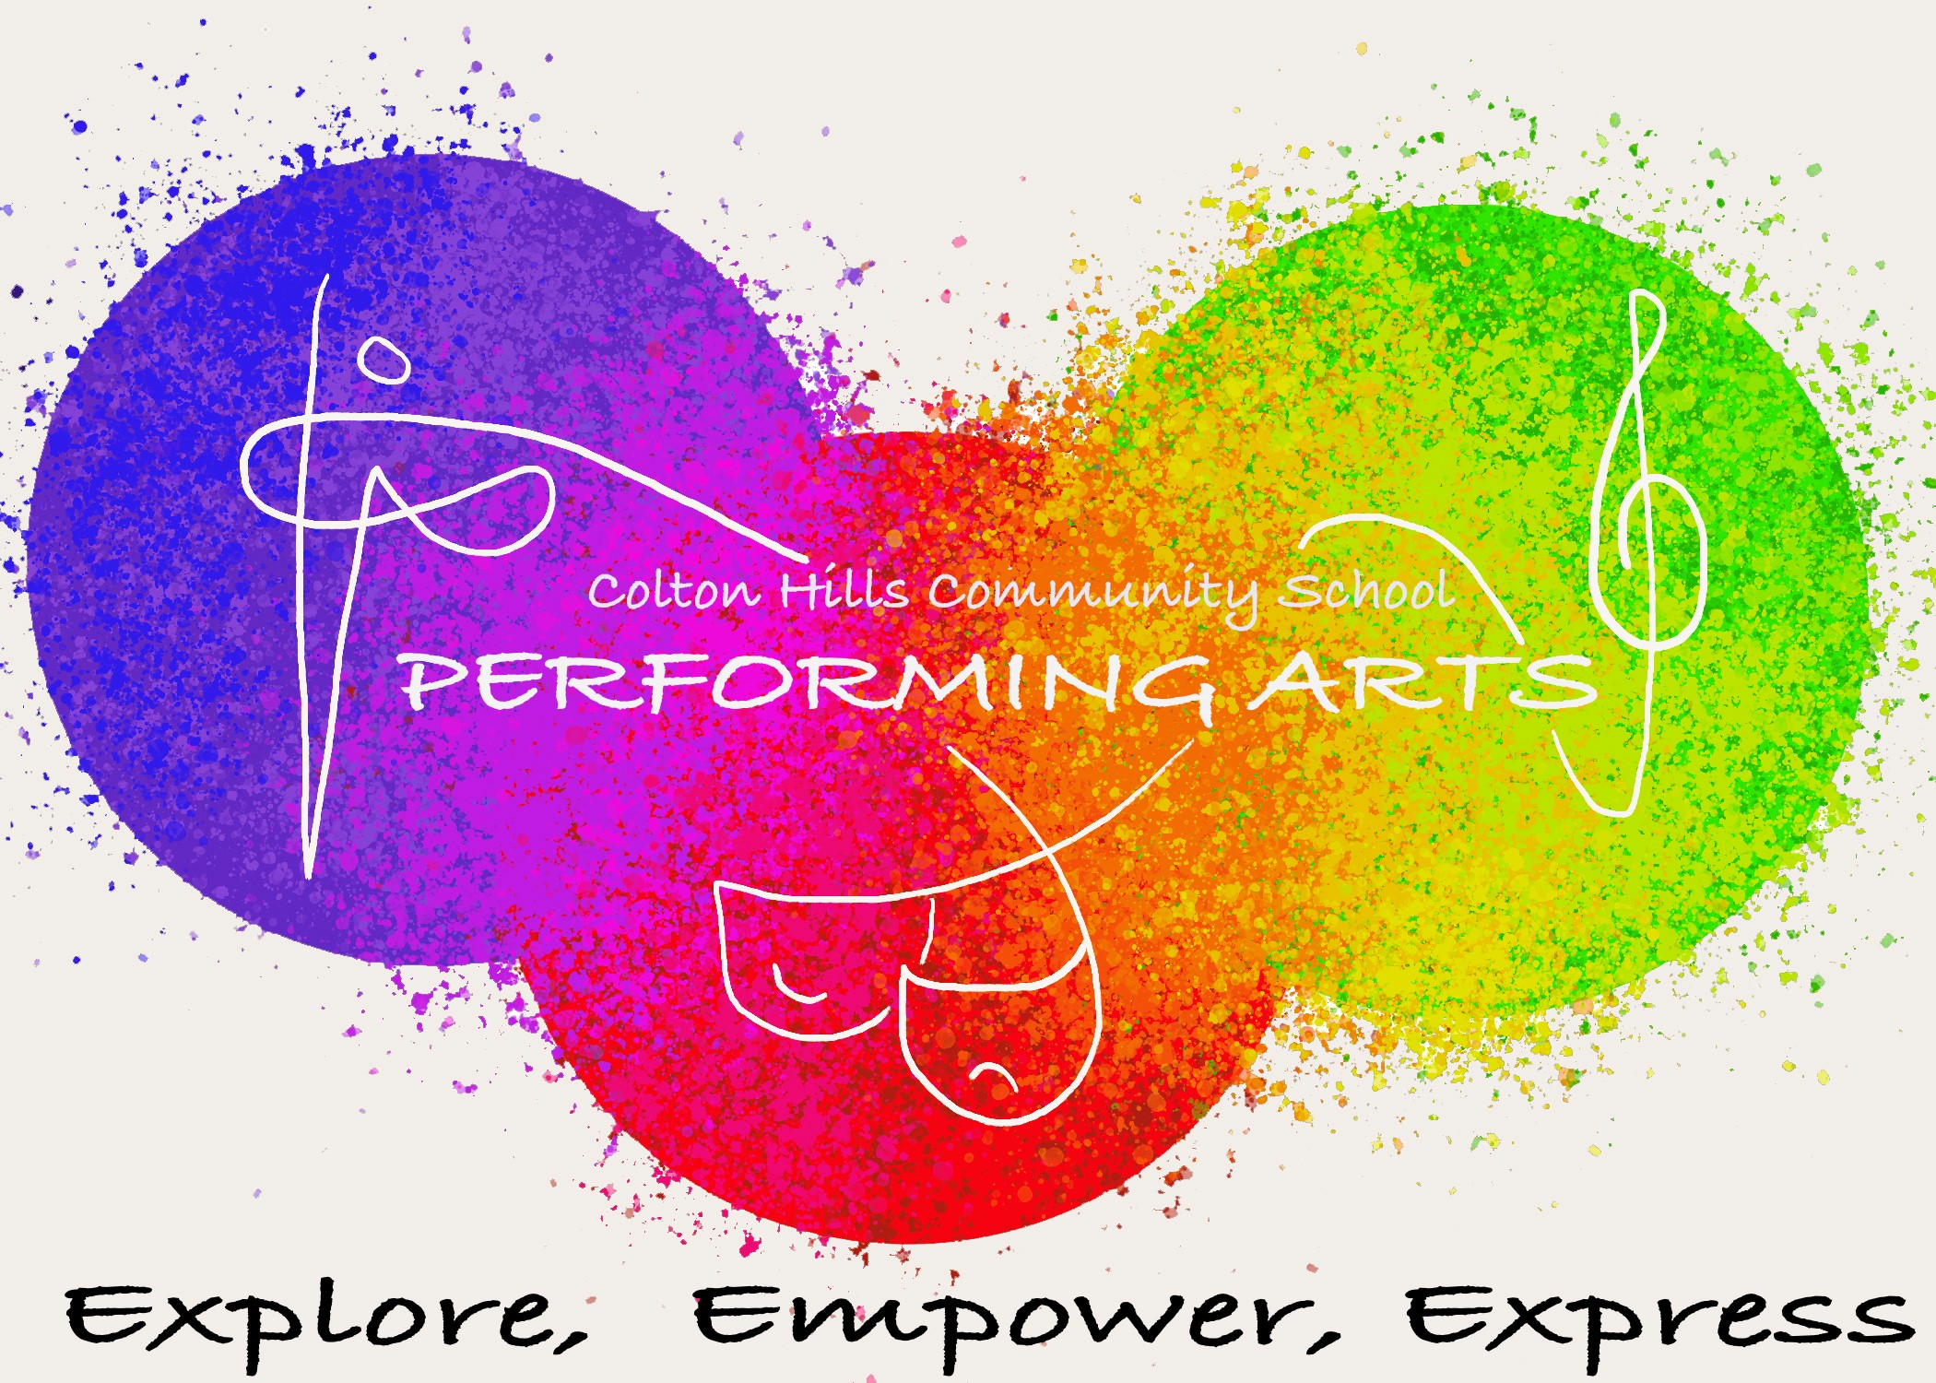

Dance

Dance

CURRICULUM PLAN

Department: Performing Arts (Drama, Dance and Music)

Vision Statement:

The arts are vital for engaging and maximising the life chances of all students by providing a stimulating, challenging and respectful environment. To develop artistically literate students who are able to fully engage with current issues and critically evaluate information.

Strapline:

Explore, Empower, Express (To explore, you will empower and creatively express)

Curriculum Story: [No more than 50 words on the story of the curriculum sequence]

Students will explore a consciously creative pathway, discovering many chorographical influences and dance styles to shape an ever growing technique, which communicates enjoyment, expression, purpose and themes.

Skills developed:

To enable young performance artists to progress to the next stage of their career and provide them with the tools they need to succeed. Each performing arts lesson embeds literacy, applied numeracy and expand upon a transferable skill set.

Year 7: Meddling in Musicality
Experiment with dynamic choreography to tackle tricky techniques and interesting influences
Topics | Why we  teach this | Links to  last topic | Links to future topics | Key skills developed | Cultural capital opportunities | Links to whole school curriculum
Half Term 1 To explore the rhythm within us.
Dance through Time | Students need to be introduced to the 5 basic actions and exposed to a high volume of movement vocabulary to saturate their understanding of dance outside of social remits. | Introduction to specific subject terminology. | To examine a way of moving and its development over time.  To explore styles and what they are. | Basic actions and movement content. There is a strong focus on RAD’s and taught movement. | Linking each dance style to the time period and changes in society that influenced the changes in dance. | History of dance and modern influences.  Developing timing, dynamics, use of space, directions, counting in beats and bars in Maths/PE
Half Term 2 To empower our cultural difference and the tradition of dance around the world
Cultural Diversity  Capoeira  And  Bhangra | Its vital students explore style from a cultural perspective to understand the variety of dance for many traditions and celebrations across the world. Focused explorations are Capoeira and Bhangra. | Developing students understanding of style and what style is.  Exposing student to the wealth and variety of movement vocabulary. | To encourage understanding of the wider world. | Investigating RAD’s for specific styles.  Analysis of choreographic devices associated with specific cultural styles. | Explore the traditions of two different countries in their use of dance for compelling reasons.  Exposing students to music in dance. | Exploration of cultural celebrations and traditions in RE/History/Geography  Discovery cultural vocabulary.
Half Term 3 To express a purpose through movement.
Swan Song  Christopher Bruce | Students will investigate how choreographers root movement in themes and the purpose of dance through a professional work related to Pinochet’s Regime in Chile in the 1980’s. | Refined movement technique. To learn repertoire To explore character and create atmosphere. | Introduction to the creative process and the intensions of dance for BTEC. | Establishing a connection between movement, themes, and intentions to effectively create tension and a purpose for movement. | Opportunity to explore thoughts, feeling and intensions. | Exploration of themes, purpose in in English, Life Skills and History.  Awareness of political powers.

Year 8: Consciously Creative
Examine influential choreographers to consciously create and craft
Topics | Why we  teach this | Links to  last topic | Links to future topics | Key skills developed | Cultural capital opportunities | Links to whole school curriculum
Half Term 1 To explore dance over time through two contrasting styles.
Old V New  Contemporary and  Street | Investigating complex techniques Contemporary and Street Dance, specifically: Tim Milgram & Old School vs New School Street Dance and Cunningham, Limon. A greater focus is on technique. | Development of specific subject terminology and verbal reasoning of movement choices. | Expand movement vocabulary both practically and verbally.  To evaluate a choreographers style | Styles of movement.  Creating choreography. Examining own practice and success of own and group work. | Development of creative movement and style technique  Listening to new music. | History of dance and modern influences.  Developing timing, dynamics, use of space, directions, counting in beats and bars in Maths/PE
Half Term 2 To empower our cultural difference and the tradition of dance around the world
Cultural Diversity  African  and  Hakka | Students explore styles from a cultural perspective to understand the variety of dance for many traditions and celebrations across the world. Focused explorations are African and Hakka. | Understanding of style  Exposing student to the wealth and variety of movement vocabulary. | To encourage understanding of the wider world. | Investigating RAD’s for specific styles.  Analysis of choreographic devices associated with specific cultural styles. | Explore the traditions of two different countries  Exposing students to music in dance. | Exploration of cultural celebrations and traditions in RE/History/Geography  Discovery cultural vocabulary.
Half Term 3 To express a purpose through movement.
Still Life at the Penguin Cafe | Examine the impact theme and style can have on a dancer’s use of technique and performance skills.  Analyse the use of the creative process in response to intentions choreographic choices. | RAD’s, Choreographic Devices, Styles, Theme, and Purpose. | Establishing and honing analytical skills and metacognition of the creative process. | Building consideration of intentions and the impact on the choreographic process | Appreciation of the role of a dancer.  Appreciation of the role of a choreographer. | Discovery of choreographers and existing repertoire in History and Geography.
Transitional SOW To give students the tools needed to explore, empower and express their creative voices.
Stimulus | Students will have explored a professional work and starting points from a pre-existing professional work. This SOW will support students to understand the process of creating and purpose of choices. | Develops understanding of professional works and stimulus points. | Taster of a blended curriculum as this fuses dance and drama. | Creative process, understanding work from the audiences perspective. | Equality, BLM, Sign Language, Adversity, In equality Hero’s. | Health and Social Care, RE, History.

Year 9: Respective Perspectives
Delve into blended disciplines of dance and drama.
Topics | Why we  teach this | Links to  last topic | Links to future topics | Key skills developed | Cultural capital opportunities | Links to whole school curriculum
Autumn Term To explore performance skills through a professional work focusing on the theme of immigration and social constructs.
Protein  Boarder Tales | This professional work blends dance and drama and focused on a theme that many students will relate to. It allows students to understand that arts disciplines do not need to sit in isolation. | Building blocks of dance and drama skills and techniques. | Introduction to a blended curriculum. | Performance skills (Physical, Technical, Expressive, Characteristic) | Social, moral, cultural and spiritual appreciation.  Awareness of others. | MFL- languages  History- Migration patterns
Spring Term To empower learners in their ability to analyse the media world.
In the Media | To understand the impact the arts have through advertising and selling products, explore how the arts can influence buyers and target audiences. | Creative process, developing purpose, theme.  Selecting skill sets for appropriate products. | Developing an awareness of target audiences | Creative process- Taught, collaborative, task led. Structures, roles and responsibilities. | Social Media influences, developing social awareness, an ability to make informed choices. | Business- marketing  ICT/Comp Science- making videos.
Summer Term 1 To express perspectives and views through creative voices.
Political Perspectives | To introduce students to political powers of the arts. Developing an understanding of Splendid Political Theatre, Dance Arts such as Rosie Kay. | Encompasses the performance and creative process skills form the prior SOW’s | Students given the freedom to express their voices and form opinions which is part of BTEC. | Performance and Creative skills combined, greater focus on drama strategies and choreographic devices. | Issues affecting the world around them, to form a voice and feel counted. | Real World Links.

Year 10: Growing Grit
Create, compose and condition performing arts practice
Topics | Why we  teach this | Links to  last topic | Links to future topics | Key skills developed | Cultural capital opportunities | Links to whole school curriculum
Autumn 1 Examine and explore the interrelationships between professional practitioners and constituent features of existing performance material.
A Chorus Line | Students will develop their understanding of the performing arts by examining the work of Michael Bennett, the styling of Jazz Dance and the processes used to create performance. | Extracting influential information and applying appropriate techniques with consistent reference to criteria. | Students will develop transferable skills, such as research and communication explored through workshops, written submissions and presentations. | Students will focus on developing research skills and how to extract research that will inform character and context conditions. | Collaboration of experiences and extracting vital information to develop the style and history of Jazz. Whilst encouraging students to develop a secure technique and a progressive understanding of their role as a dancer. | Exploration of research processes in Science, Geography and History. Analysing use of language in English and MFL.
Autumn 2 Examine and explore the interrelationships between professional practitioners and constituent features of existing performance material.
Broken | Students will develop their understanding of the performing arts by examining the work of Motionhouse, the styling of Contemporary Dance and the processes used to create performance. | Extracting influential information and applying appropriate techniques with consistent reference to criteria. | Students will develop transferable skills, such as research and communication explored through workshops, written submissions and presentations. | Students will establish and hone skills in making critical comparisons through recognising similarities and differences between contexts, practises and roles (responsibilities and skills). | Collaboration of experiences and extracting vital information to develop the style and history of Contemporary. Whilst encouraging students to develop a secure technique and a progressive understanding of their role as a dancer. | Exploration of research processes in Science, Geography and History. Analysing use of language in English and MFL.
Spring 1 Examine and explore the interrelationships between professional practitioners and constituent features of existing performance material.
Emancipation of Expression | Students will develop their understanding of the performing arts by examining the work of Boy Blue, the styling of Lyrical Hip-Hop Dance and the processes used to create performance. | Extracting influential information and applying appropriate techniques with consistent reference to criteria. | Students will develop transferable skills, such as research and communication explored through workshops, written submissions and presentations. | Students will establish and hone skills in making critical comparisons through recognising similarities and differences between contexts, practises and roles (responsibilities and skills). | Collaboration of experiences and extracting vital information to develop the style and history of Lyrical Hip-Hop. Whilst encouraging students to develop a secure technique and a progressive understanding of their role as a dancer. | Exploration of research processes in Science, Geography and History. Analysing use of language in English and MFL.
Spring 2 Develop, apply and review own development of skills, techniques and contribution to the performance.
Jazz & Ballet Technique Workshops | Students will develop their dance skills and techniques through the reproduction of Jazz & Ballet Technique Exercises and Repertoire exploring the style and their technical development. | Students will work from existing Ballet & Jazz repertoire, applying relevant skills and techniques to reproduce exercises and techniques. | Students will develop transferable skills, such as research and communication explored through workshops, written submissions and presentations. | Students will begin to acknowledge and recognise (audit) skills as a performer in one’s self, peers and professional performers. Students will assess and examine qualities for further improvement and generate a plan to support. | Collaboration of experiences and extracting vital information to develop the style and history of Jazz & Ballet Technique and Repertoire. Whilst encouraging students to develop a secure technique and a progressive understanding and connection with their bodies. | Exploration of research processes in Science, Geography and History. Analysing use of language in English and MFL.
Summer 1&2 Develop, apply and review own development of skills, techniques and contribution to the performance.
A Chorus Line | Students will develop their dance skills and techniques through the reproduction of A Chorus Line Repertoire exploring the style and their technical development. | Students will work from existing Ballet & Jazz repertoire, applying relevant skills and techniques to reproduce exercises and techniques. | Students will develop transferable skills, such as research and communication explored through workshops, written submissions and practical performance | Students will begin to acknowledge and recognise (audit) skills as a performer in one’s self, peers and professional performers. Students will assess and examine qualities for further improvement and generate a plan to support. | Collaboration of experiences and extracting vital information to develop the style and history of Jazz & Ballet Technique and Repertoire. Whilst encouraging students to develop a secure technique and a progressive understanding and connection with their bodies. | Exploration of research processes in Science, Geography and History. Analysing use of language in English and MFL.

Year 11: Making Moments
Create, compose and condition performing arts practise.
Topics | Why we  teach this | Links to  last topic | Links to future topics | Key skills developed | Cultural capital opportunities | Links to whole school curriculum
Autumn 1 and 2 Select, apply and evaluate the skills and techniques used in the development process and outcome in response to a brief.
Component 3 Mock | Students will be given the opportunity to work as part of a group to contribute to a workshop performance as a performer in response to a given brief and stimulus. | Collaboration of experiences and extracting vital information from the given brief and stimulus. Students will apply their knowledge of practitioners and performance styles to their own creative work. | Students will have developed transferable skills to support them in further and higher performing arts education. | Students will practise the creative and evaluative processes required for Component 3. Students will participate in workshops to gather research, develop leadership and directorial skills with their peers. | Collaboration of experiences and extracting vital information to empower the developed characters. Whilst encouraging students to develop a secure technique and a progressive understanding and connection with their bodies. | Exploration of research processes in Science, Geography and History. Analysing use of language in English and MFL.  Examining composition in Art.
Spring 1 and 2 and Summer 1 Select, apply and evaluate the skills and techniques used in the development process and outcome in response to a brief.
Component 3 Exam  Exam released in January. | Students will be given the opportunity to work as part of a group to contribute to a workshop performance as a performer in response to a given brief and stimulus. | Collaboration of experiences and extracting vital information from the given brief and stimulus. Students will apply their knowledge of practitioners and performance styles to their own creative work. | Students will have developed transferable skills to support them in further and higher performing arts education. | Students will practise the creative and evaluative processes required for Component 3. Students will participate in workshops to gather research, develop leadership and directorial skills with their peers. | Collaboration of experiences and extracting vital information to empower the developed characters. Whilst encouraging students to develop a secure technique and a progressive understanding and connection with their bodies. | Exploration of research processes in Science, Geography and History. Analysing use of language in English and MFL.  Examining composition in Art.

