English
Year 7 Autumn Term

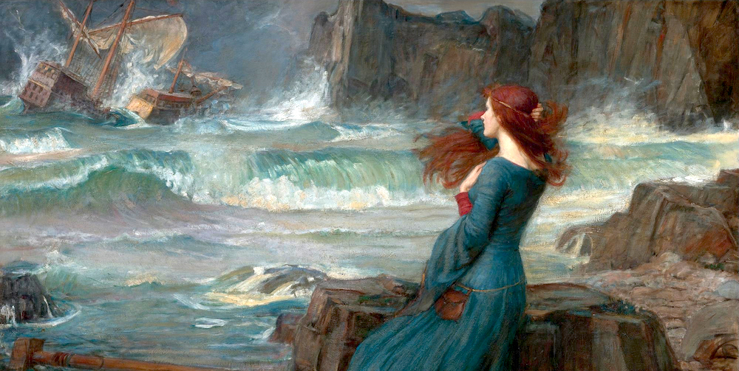

The Tempest
Knowledge and Assessment Organiser

Student name: ………………………………….
How does Shakespeare present the island and its characters as magical?

Contents
What’s the story? | Page 3
Key Terms | Page 4
Key People | Page 5
Big and Small Questions | Page 6
Curricular Concepts | Page 7
Essential Knowledge | Pages 8-43
Examples of Student Answers | Page 45
Flipped Learning | Pages 46-48

Why does this matter?

- We are studying the works of one of the most important playwrights in the English language.
- It is vital that we are aware of writing that pre-dates modern times.
- We must be able to read, understand and interpret Shakespeare’s work as a prerequisite to future work we will undertake later on in our school life.

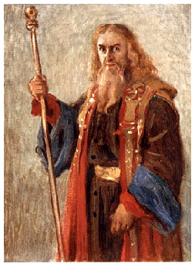
What’s the Story?
Hi, I’m Prospero. You might not have heard of me before but once we meet you’ll never forget who I am. See I’m the kind of guy that definitely leaves an impression. Do you believe in magic? I do. In fact, I’ve read every book there is on the subject. I have forgotten more charms and spells than you’ll ever know. If I click my fingers right now, you’ll fall asleep. With the slightest wave of a hand, I can start a storm that’ll wreak a ship.
I’m not the kind of guy you’ll want to mess with.
Just ask Caliban. This ugly freak is now my servant. His mum was a witch - on this island - who had taught him to worship the demonic god, Setebos. She died - leaving her poor sprit helper Ariel trapped in a tree. Then I came along, freed the sprit and quickly showed Caliban who’s boss.
Bet you’re thinking how do I get these kinds of skills? Well first you’ll need a big set of magic books and second you need time. Lots of time. And time is precisely the thing that I’ve had lots of these past twelve years.
You see once upon a time I was the Duke of Milan. I know pretty important, right. Except, to be honest, I was sort of bored. It was all just meetings, meetings and more meetings. ‘Can you do this?’ and ‘Can you sort that?’. Boooooooooooring. So I let my brother Antonio make most of the decisions and deal with all those annoying peasants who wanted me to solve their problems for them.
Big mistake.
Now, here’s the thing, I bet you have a nice brother. Yes maybe he’s a bit annoying but, chances are, he’s not arranged to have you and your daughter kidnapped, put you in a raft at sea and left you to die. No, compared to that scumbag Antonio and his evil pal Alonso (the king of a nearby Town), your brother is probably an angel.
Now there I was adrift, miles from anywhere, sea sick and trying to put on a brave face so that Miranda, my daughter, didn’t start to panic. And what do I see on the horizon. An island: fortunately, we put ashore that evening.
Islands can be pretty weird places. Walking around at first I thought this one was deserted. And then I heard it. Strange sounds were coming from a tree near the beach. Crying sounds, like nothing I had ever heard. A quick release spell later and there it was: Ariel. Now I’m not going to lie having a spirit like Ariel in your debt because you freed her from a tree that an evil witch had trapped her in is kinda cool – it’s also super useful. Ariel is a bit like a cross between a really good butler (like that guy from Downtown Abbey) and Professor Xavier in X Men.
It’s especially useful when you see a boat carrying Alonso (remember that evil king who helped my brother steal my crown), Ferdinand (his weird son), Antonio (my scum bag brother), Gonzalo (nice guy – packed some stuff in the raft – if it wasn’t for him I’d be dead) and two crazy servants Stephano, and Trinculo. They were all supposed to be on their way to Italy, after coming from the wedding of Alonso’s daughter. I know what you’re think: what a coincidence. All the people who were involved in your betrayal just happening to be on their way back from a wedding and they just happen to run into a storm near the island that you’ve been trapped on for twelve years with your daughter.
Well in this world nothing’s a coincidence.
So what’s my game plan then? Well, that’s easy. Get Ariel to magic all the ship’s passengers ashore, split them up and distribute them all around the island. Get Ferdinand to fall in love with my daughter, and finally get my revenge. What could possibly go wrong?
Key Terms

- Aetiological (adjective) - serving to explain something by giving a cause or reason for it, often in historical or mythical terms.
- Allusion (noun) - an expression designed to call something to mind without mentioning it explicitly; an indirect or passing reference.
- Archetypal (adjective) - very typical of a certain kind of person or thing.
- Hubris (noun) - excessive pride or self-confidence.
- Metamorphosis (noun) - a change of the form or nature of a thing or person into a completely different one.
- Moral (noun) - a lesson that can be derived from a story or experience.
- Mortal (adjective) - (of a living human being, often in contrast to a divine being) subject to death.
- Myth (noun) - a traditional story, especially one concerning the early history of a people or explaining a natural or social phenomenon, and typically involving supernatural beings or events.
- Nemesis (noun) - the inescapable agent of someone's or something's downfall.
- Stereotypical (adjective) - relating to a widely held but fixed and oversimplified image or idea of a particular type of person or thing.
- Temptation (noun) - the desire to do something, especially something wrong or unwise.
- Vengeance (noun) - punishment inflicted or retribution exacted for an injury or wrong.

- Analyse (verb) - examine (something) methodically and in detail, typically in order to explain and interpret it.
- Inference (verb) – predict or guess (something) from evidence and reasoning rather than from explicit statements.
- Quote (verb) - repeat or copy out (words from a text or speech written or spoken by another person).

Key People
William Shakespeare: (26 April 1564 – 23 April 1616)
Shakespeare was an English playwright, poet, and actor, widely regarded as the greatest writer in the English language and the world's greatest dramatist. He is often called England's national poet and the "Bard of Avon" (or simply "the Bard"). His existing works, including collaborations, consist of some 39 plays, 154 sonnets, three long narrative poems, and a few other verses, some of uncertain authorship. His plays have been translated into every major living language and are performed more often than those of any other playwright. They also continue to be studied and reinterpreted.
Characters:
- Prospero
- Caliban
- Ariel
- Miranda
- Ferdinand
- Alonso
- Stephano
- Gonzalo
- Sycorax
- Trinculo
- Antonio
How does Shakespeare present the island and its characters as magical?

What methods and language devices can a writer use to create a good ending for their story?
Why are stories that are set on a deserted island interesting?
How can a scene hold an audience’s attention?
What would make someone kill?
How does Shakespeare use language to create a strange and unusual atmosphere in the play?
What can we learn about Prospero’s relationship with his family?
How can we make inferences about how an environment impacts on a character?

Curricular Concepts
Have you ever noticed how some of the things you study in one subject appear in another subject too?

Students are able to understand their work more and remember more if there are clear links between subjects. Throughout your learning at Colton Hills, we will be asking you to think about some of the most important ideas in the world to enable your learning to be deeper than ever before. Look for these ‘curricular concepts’ in your learning.

Essential Knowledge

Man and the Natural World
Small question 1:
How can we make inferences about how an environment impacts on a character?

The Tempest - Act 1 Scene 1
Setting the scene: “Close to a Mediterranean island, a storm overcomes a ship that carries King Alonso of Naples, his son Ferdinand, and his brother Sebastian. They were on their way home home from Tunis to Italy when the storm hit and demolished their ship. Shipwrecked with them are the courtier, Gonzalo, and the Duke of Milan, Antonio.”

Early Modern Version | Modern Day version
A tempestuous noise of thunder and lightning heard Enter a MASTER and a BOATSWAIN | Loud noises of a storm with thunder and lightning. A ship’s MASTER and BOATSWAIN enter.
MASTER  Boatswain! | MASTER  Boatswain!
BOATSWAIN  Here, master. What cheer? | BOATSWAIN  I’m here, sir. How can I help you?
MASTER  Good, speak to th' mariners. Fall to ’t yarely, or we run ourselves aground. Bestir, bestir. | MASTER  My good boy, give the other sailors a pep talk—and do it fast, before we’re shipwrecked. Hurry, hurry!
Exit MASTER | The MASTER exits.
Enter MARINERS | SAILORS enter.
BOATSWAIN  Heigh, my hearts! Cheerly, cheerly, my hearts! Yare! Yare! | BOATSWAIN  Come on, men! That’s the way to do it! Quickly! Quickly!
Enter ALONSO, SEBASTIAN, ANTONIO, FERDINAND, GONZALO, and others | ALONSO, SEBASTIAN, ANTONIO, FERDINAND, GONZALO, and others enter.
ALONSO  Good Boatswain, have care. Where’s the Master? | ALONSO  Be careful, good Boatswain! Where’s the Master?
BOATSWAIN  I pray now, keep below. | BOATSWAIN  Please stay below deck, sir.
ANTONIO  Where is the Master, Boatswain? | ANTONIO  Where’s the Master, Boatswain?
BOATSWAIN  Do you not hear him? You mar our labor. Keep your cabins.  You do assist the storm. | BOATSWAIN  He’s busy, can’t you hear him giving orders? You’re getting in the way of our work. Stay in your cabins. You’re helping the storm, not us.
GONZALO  Nay, good, be patient. | GONZALO  Don’t get wound up, my good man.
BOATSWAIN  When the sea is. Hence! What cares these roarers for the name of king? To cabin, silence! Trouble us not. | BOATSWAIN  I’m only wound up because the sea’s wound up. Now get out of here! Do you think these waves care anything about kings and officials? Go to your cabins and be quiet! Don’t bother us up here.

Sea Shanty: Ship in Distress
You seamen bold who plough the ocean
See dangers landsmen never know.
'Tis not for honour or promotion;
No tongue can tell what they undergo.
In the blusterous wind and the great dark water
Our ship went drifting on the sea,
Her headgear gone, and her rudder broken,
Which brought us to extremity.

For fourteen days, heartsore and hungry,
Seeing but wild water and bitter sky,
Poor fellows they stood in a totter,
A-casting lots as to which should die.
The lot it fell on Robert Jackson,
Whose family was so very great.
“I'm free to die, but oh, my comrades,
Let me keep look-out till break of day.”

A full dressed ship like the sun a-glittering
Came bearing down to their relief.
As soon as this glad news was shouted,
It banished all their care and grief.
The ship brought to, no longer drifting,
Safe in Saint Vincent, Cape Verde, she gained.
You seamen all, who hear my story,
Pray you'll ne'er suffer the like again.

Chasing ocean storms
The storm was above me, illuminating the sand and sea around me with regular flashes of light, brilliant bolts from above, fierce and serene. With each electric fork driven into the waters around me, a feeling of gratitude and privilege welled up within me. I had timed things perfectly. I was in the heart of an ocean storm.
With the sky shape-shifting and burbling above, the data holding steady for a great show, it was time to wait. As with most photography, the pursuit of beautiful images comes with a great deal of patience. And luck. My fingers remained crossed for the remainder of the day. They would unravel with the arrival of the storm, ready for the shutter button.
Towering clouds reached upwards, stretching for the stratosphere and all that lay beyond. Blue sky retreated, along with the fading sun. As golden light illuminated the sides and undercarriages of the bulbous giants that loomed overhead, the air seemed to both cool and thicken. The horizon darkened to a chalkboard black, a zig zag of molten orange breaking through the distant sheets of tumbling rain, horizontal lava flows in a sea of ash. Claps of thunder rolled over land and water toward me.
The storm was here.
Storms are a sort of magic for me. The colours and sounds, the twisting masses of clouds and jagged lines of light that connect sky to sea. Some of civilisation’s greatest mythological characters and stories come from the tumultuous realm above, a place of power and might. It has forever been a source of intrigue and mystery for our species, and now is no different – except for the fact we are able to capture that godly magic with the touch of a button.

The Tempest - Act 1 Scene 1
Setting the scene: “The royal party and the other mariners, with the exception of the unflappable Boatswain, begin to fear for their lives. Lightning cracks, and the mariners cry that the ship has been hit. Everyone prepares to sink.”
Early Modern Version | Modern Day Version
Enter MARINERS, wet | More SAILORS enter, wet.
MARINERS  All lost! To prayers, to prayers, all lost! | SAILORS  It’s no use! Pray for your lives! We’re done for!
Exit MARINERS | The SAILORS exit.
BOATSWAIN  What, must our mouths be cold? | BOATSWAIN  What, we’re going to die?
GONZALO  The king and prince at prayers. Let’s assist them, for our case is as theirs. | GONZALO  The king and the prince are praying. Let’s go join them, since whatever happens to them happens to us too.
SEBASTIAN  I’m out of patience. | SEBASTIAN  I’m out of patience.
ANTONIO  We are merely cheated of our lives by drunkards. This wide-chopped rascal—would thou mightst lie drowning the washing of ten tides! | ANTONIO  Yes, we’ve been cheated out of our lives by a bunch of drunken, incompetent sailors. This bigmouth jerk here—(to BOATSWAIN) I hope you drown ten times over!
GONZALO  He’ll be hanged yet, though every drop of water swear against it and gape at widest to glut him. | GONZALO  He’ll still die by hanging, not drowning, even if every drop of water in the sea tries to swallow him.
A confused noise within | A confused noise offstage.
VOICES  (within) Mercy on us!—We split, we split!—Farewell, my wife and children!—Farewell, brother!—We split, we split, we split! | VOICES  God have mercy on us!—The ship’s breaking up!—Goodbye, wife and kids!—Goodbye, brother!—We’re breaking up, we’re breaking up!
ANTONIO  Let’s all sink wi' th' king. | ANTONIO  Let’s all sink with the king.
SEBASTIAN  Let’s take leave of him. | SEBASTIAN  Let’s say goodbye to him.

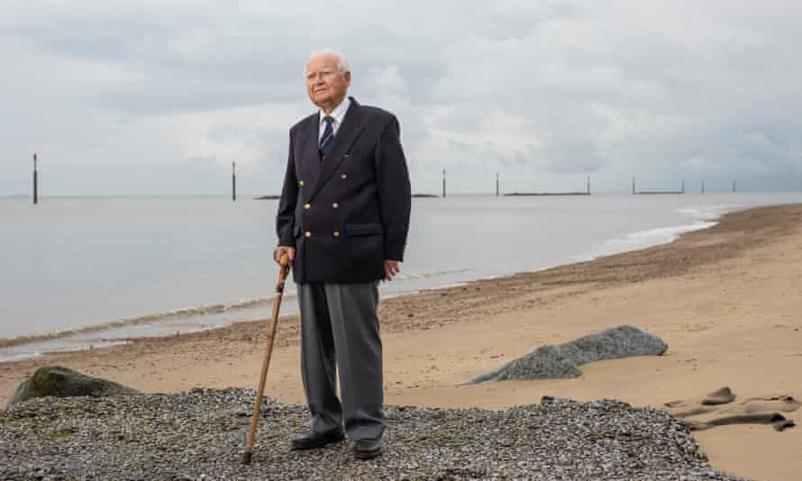
Experience: I survived 15 days adrift on a raft

A gunner drank seawater and he went daft and swam away. A third officer shouted for his mother and went over the side.
I was 15 when I went to sea. When the second world war broke out, our school in Stockton-on-Tees was taken over by the civil service, and my headteacher allowed me to leave. He said to me: “Colin, everything is so upside down you won’t be missed.”
I trained for six months and joined SS Rio Azul, a cargo steamer, as a deck boy in the merchant navy. My first voyage was to Freetown, Sierra Leone, to collect iron ore for the war effort. On our journey home, we were escorted in a convoy of more than 20 ships by HMS Esperance Bay. Unfortunately the “wolf pack” – German U-boats – picked us up.
We lost ships every day of the journey. Eventually, the commodore of HMS Esperance Bay told the convoy to scatter – this would lessen the chance of being attacked. We were alone for two days before being torpedoed by a U-boat in the early evening of 29 June 1941. The ship went down in 50 seconds. You don’t know how fast you can run until it happens.
I climbed a short ladder and got on to the boat deck. The water was already at deck level. The boatswain said, “The lifeboats are smashed.” We only had rafts – two 45-gallon drums laced together with wooden batons. I grabbed the raft just as the stern of the ship went down. As I went under water, all I was thinking was: if this raft is tied to the ship, I’ll have to let go, because I haven’t got a knife to cut it away. But suddenly we were going up, and I resurfaced, clinging to the raft. It was dark. People called for help. One chap shouted: “How do you swim?” It was a bit too late to teach him. We ended up with 18 people on the raft or hanging from the sides. When the last shouts died away, there was silence.
The boatswain was in charge. We had a demijohn holding a gallon of fresh water and our ration was one capful – about three teaspoons – a day. We distributed a tin of powdered egg and one of molasses by dipping a stick in water, then in the powder, before licking the stick.
I remember wearing a vest, underpants and a life-jacket. The sun burned, so we took turns on the raft and in the water. Those in the ocean threw water over those on top. After three or four days, we saw smoke on the horizon from a passing ship. Morale rose, but we were very low in the water and had no flares. The smoke disappeared. Morale dropped to the bottom. We didn’t sing, and we didn’t talk much. We tried to save energy and stay calm. There were no arguments, although some people tried to get an extra helping of water. When a chap is dying your first thought is, give him some water; but if he’s dying, what the devil are you giving it to him for?
The head steward was in his 60s and he was the first to go over the side. A gunner drank seawater and he went daft and swam away. A young third officer shouted for his mother and then went over. I was going in for him, but the boatswain said, “Stay where you are – you can’t do anything for him.” Two others just disappeared without a word.It’s a hard thing to explain, but the feeling was just: “So-and-so’s gone, that’s bad luck.” I thought, “Oh gosh, I haven’t seen anything of life yet,” but I never gave up hope.
After 15 days on the raft, we saw smoke again. This time, I stood with seamen supporting me and waved an oar that held a cigarette tin. The ship’s lookout saw it glint in the sunlight. It was HMS Esperance Bay. We were so weak that their seamen had to carry us on to deck. The boatswain died when he got on to the ship. There were just eight survivors from the ship’s company of 42; I survived because I was young and fit. We had drifted 200 miles south of the Azores.
My parents were told my ship had been torpedoed and I was presumed lost at sea. On the day I came home, my brother opened the door and slammed it shut: he thought he’d seen a ghost.
I received a small pension but became bored at home, and so I spent the next 11 years at sea. For years after being on the raft, I would wake at night not knowing where I was and only that I had to get out. I’d get up and be soaked in perspiration. I suffered with that for a long time, but I thought I was going crackers so I didn’t tell anybody.
I married Margaret, we had two children and I’ve had a good life. I was lucky. But we haven’t had many holidays at sea. If they want me to go, they’ll have to pay me.

The Wreck of the Hesperus - by Henry Wadsworth Longfellow
It was the schooner Hesperus,
That sailed the wintry sea;
And the skipper had taken his little daughter,
To bear him company.
Blue were her eyes as the fairy flax,
Her checks like the dawn of day,
And her bosom white as the hawthorn buds,
That ope in the month of May.
The skipper, he stood beside the helm,
His pipe was in his mouth,
And he watched how the veering flaw did blow
The smoke now west, now south.
Then up and spake an old sailor,
Had sailed to the Spanish Main,
"I pray thee, put into yonder port,
For I fear the hurricane.
"Last night, the moon had a golden ring,
And to-night no moon we see!"
The skipper, he blew a whiff from his pipe,
And a scornful laugh laughed he.
Colder and louder blew the wind,
A gale from the northeast;
The snow fell hissing in the brine,
And the billows frothed like yeast.
Down came the storm, and smote amain
The vessel in its strength;
She shuddered and paused, like a frighted steed,
Then leaped her cable's length.
"Come hither! come hither! my little daughter,
And do not tremble so;
For I can weather the roughest gale
That ever wind did blow."
He wrapped her warm in his seaman's coat,
Against the stinging blast:
He cut a rope from a broken spar,
And bound her to the mast.
"O father! I hear the church bells ring,
Oh say, what may it be?"
"'Tis a fog bell on a rock-bound coast!"
And he steered for the open sea.
"O father! I hear the sound of guns,
Oh say, what may it be?"
"Some ship in distress, that can not live
In such an angry sea!"
"O father! I see a gleaming light,
Oh say, what may it be?"
But the father answered never a word,
A frozen corpse was he.
Lashed to the helm, all stiff and stark,
With his face turned to the skies,
The lantern gleamed through the gleaming snow
On his fixed and glassy eyes.
Then the maiden clasped her hands, and prayed
That saved she might be;
And she thought of Christ, who stilled the wave
On the lake of Galilee.
And fast through the midnight dark and drear,
Through the whistling sleet and snow,
Like a sheeted ghost, the vessel swept
Tow'rds the reef of Norman's Woe.
And ever the fitful gusts between
A sound came from the land:
It was the sound of the trampling surf
On the rocks and the hard sea sand.
The breakers were right beneath her bows,
She drifted a dreary wreck,
And a whooping billow swept the crew
Like icicles from her deck.
She struck where the white and fleecy waves
Looked soft as carded wool,
But the cruel rocks, they gored her side
Like the horns of an angry bull.
Her rattling shrouds, all sheathed in ice,
With the masts, went by the board;
Like a vessel of glass, she stove and sank,
Ho! ho! the breakers roared!
At day break, on the bleak seabeach,
A fisherman stood aghast,
To see the form of a maiden fair
Lashed close to a drifting mast.
The salt sea was frozen on her breast,
The salt tears in her eyes;
And he saw her hair, like the brown seaweed,
On the billows fall and rise.
Such was the wreck of the Hesperus
In the midnight and the snow:
Heav'n save us all from a death like this
On the reef of Norman's Woe!

Betrayal
Small question 2:
What can we learn about Prospero’s relationship with his family?

The Tempest – Act 1 Scene 2
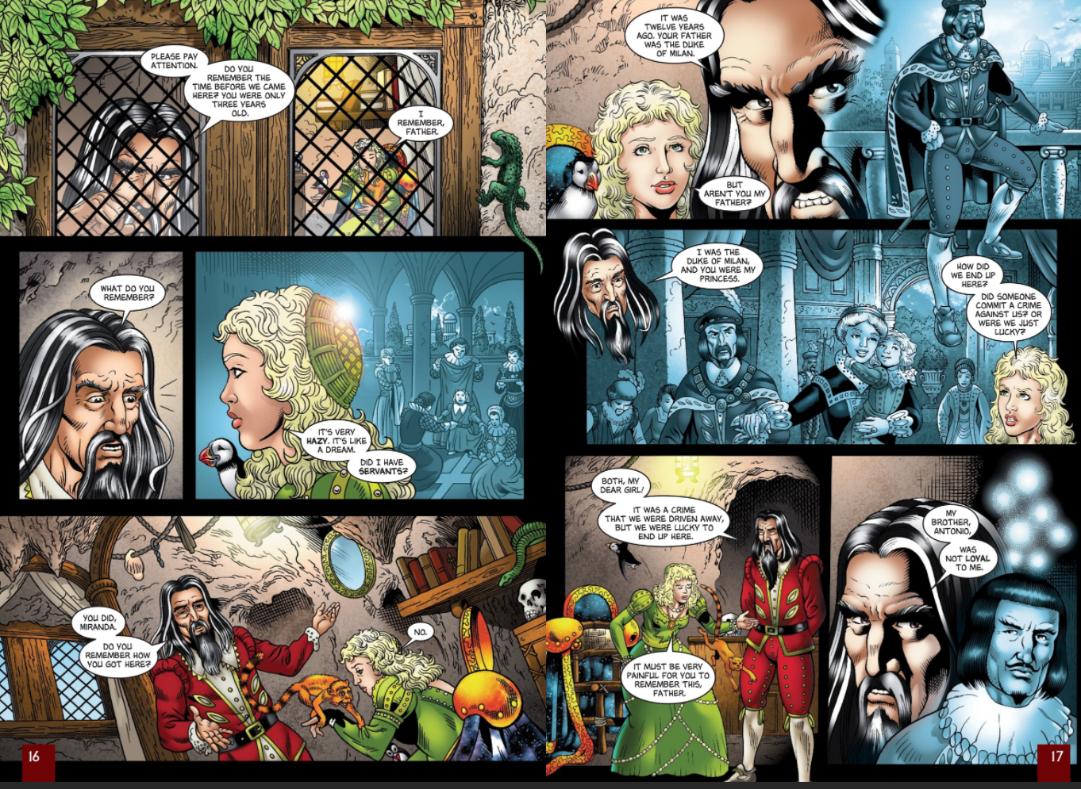
Setting the scene: From the island, Prospero, the former Duke of Milan, watches the storm and shipwreck with his 15 year-old daughter, Miranda. Miranda fears for the ship's crew, but Prospero assures her that everything is fine. He decides to open up about his past, telling her how 12 years previously, his brother Antonio had deposed him in a coup.

Early Modern Version | Modern Day Version
PROSPERO  Twelve year since, Miranda, twelve year since,  Thy father was the Duke of Milan and  A prince of power. | PROSPERO  Twelve years ago, Miranda, twelve years ago your father was the Duke of Milan, a powerful prince.
MIRANDA  Sir, are not you my father? | MIRANDA  Aren’t you my father?
PROSPERO  Thy mother was a piece of virtue and  She said thou wast my daughter. And thy father  Was Duke of Milan, and thou his only heir  And princess no worse issued. | PROSPERO  Your mother was extremely virtuous, and she said you were my daughter. And your father was Duke of Milan, and you were his heir, a princess.
MIRANDA  Oh, the heavens!  What foul play had we that we came from thence?  Or blessè was ’t we did? | MIRANDA  Good lord! What evil things were done to us that we were driven here? Or was it a blessing that we came here?
PROSPERO  My brother and thy uncle, called Antonio—  I pray thee, mark me (that a brother should  Be so perfidious!)—he whom next thyself  Of all the world I loved and to him put  The manage of my state, as at that time  Through all the signories it was the first,  And Prospero the prime duke, being so reputed  In dignity, and for the liberal arts  Without a parallel. Those being all my study,  The government I cast upon my brother  Thy false uncle—  Dost thou attend me? | PROSPERO  My brother, your uncle Antonio—just listen to this (I still can’t believe a brother could be so disloyal!)—My brother whom—aside from you—I loved more than anyone else in the world, I trusted to run my state, which at that time was the strongest in the land, and Prospero the number one duke, famous for my dignity and my education. Since I was so drawn to studying things like logic, grammar, geometry, and astronomy, I let my control of the government transfer to my brother - your disloyal uncle—are you paying attention?
MIRANDA  Sir, most heedfully. | MIRANDA  I’m hanging on every word.
PROSPERO  Being once perfected how to grant suits,  How to deny them, who t' advance and who  To trash for overtopping, new created  The creatures that were mine, I say—or changed 'em,  Or else new formed 'em—having both the key  Of officer and office, set all hearts i' th' state  To what tune pleased his ear, that now he was  The ivy which had hid my princely trunk,  And sucked my verdure out on ’t. Thou attend’st not. | PROSPERO  Once Antonio got the knack of granting certain requests, denying others, promoting some officials and keeping down those who were getting too ambitious, he won over the people who used to be mine, or changed them—remade them, you might say. Since he had control over the whole government and everyone in it, he soon made everyone sing his own song—whichever song he happened to like. He became like the ivy that sticks to the side of the tree, and sucked my vitality out of me.—You’re not paying attention.
MIRANDA  O, good sir, I do. | MIRANDA  Oh, yes I am, father.

'I’ve never got over their betrayal': How being cut out of a will poisons your life forever and tears your family apart
My father Alexander had cancer for four years before he died, and I spent that time looking after him in the family home - the house in which I’d been born and had lived all my life. I was just 28, and my mother had died three years before his diagnosis.
And yet, when father finally passed away in 1978, that house was given to my brother and I was left with nothing. In fact, I was given precisely four weeks to get out of it, despite having nowhere else to go and no money.
It turned out that father’s will was changed just days before he went into a coma from which he never awoke. This was when he was very close to death, and I later discovered that it was his sister’s doing.
Going through my father’s things, I found a letter from her in which she urged him to amend the will and cut me out. She also arranged for a solicitor to visit father in hospital and make the changes.
Why she did this I’ll never know for sure - I barely knew her, and she’s dead now, too - but I think it may have been jealousy and anger at my decision to go to university.
I was the first in the family to do so, and she certainly seemed to disapprove of it, even though I was given compassionate leave after just three months to come back and look after father. But that act - the change of my father’s will to disinherit me - has had a profound effect on my life.
To be honest, I’ve never really got over it. I cared for him at his most frail and vulnerable, and yet I was cast aside at the end. In his last days my father signed a will that effectively made me homeless. For my own peace of mind, I can’t believe that he did it voluntarily. It may have been that he didn’t even know what he was signing: I have seen his signature on the will and it’s the hand of a very ill man.
When he was at the hospital, shortly before he went into that coma, a nurse asked him to nod his head if he knew that I was there, sitting at his bedside. He nodded, and for the first time in my life I saw tears roll down his cheeks.
Sometimes I think he was crying because he was confused - did he know that he’d done something wrong, or that he’d been forced to make changes to his will against his wishes by his overbearing sister? Worse, it completely ruined the relationship I had with my brother, and we haven’t spoken to each other ever since.
I strongly believe that all families should sit down together and talk about what’s in a will before a person gets sick, and certainly before death. It’s very important that everyone hears those last wishes and understands them. The worst thing of all is to be left in a state of shock - emotionally and financially - without ever being able to ask for an explanation. Because that’s the kind of trauma that echoes down a life.

The Tempest – Act 1 Scene 2
Setting the scene: “The story goes that Prospero was the Duke of Milan until his brother Antonio, conspiring with Alonso, the King of Naples, usurped his position. Kidnapped and left to die on a raft at sea, Prospero and his daughter survive because Gonzalo leaves them supplies and Prospero’s books, which are the source of his magic and power. Prospero and his daughter arrived on the island where they remain now and have been for twelve years. Only now, Prospero says, has Fortune at last sent his enemies his way, and he has raised the tempest in order to make things right with them once and for all.”

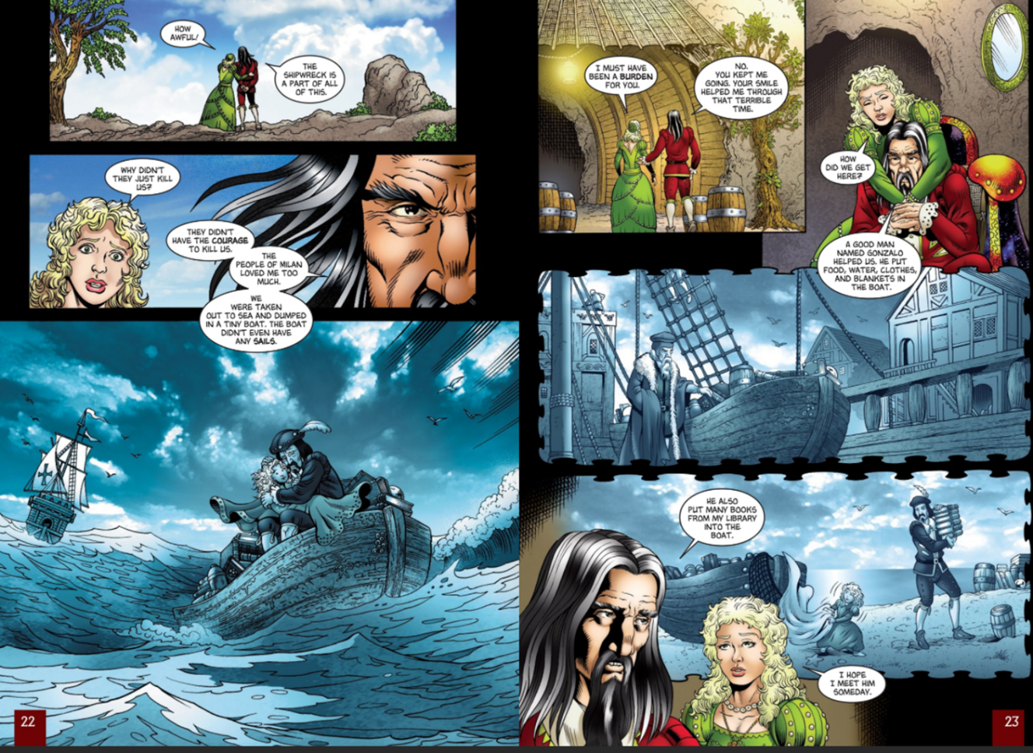
Early Modern Version | Modern Day Version
PROSPERO  To have no screen between this part he played  And him he played it for, he needs will be  Absolute Milan. Me, poor man, my library  Was dukedom large enough.  So dry he was for sway—wi' th' King of Naples  To give him annual tribute, do him homage,  Subject his coronet to his crown and bend  The dukedom yet unbowed—alas, poor Milan!—  To most ignoble stooping. | PROSPERO  To make his political performance absolutely perfect, he simply had to become the Duke of Milan himself. My library was a large enough dukedom for me. Antonio was so power-hungry that he allied himself with the King of Naples, agreeing to pay him a regular annual sum, swear subservience to him, and put the dukedom of Milan—never subservient to anyone before!—under the humiliating control of Naples.
MIRANDA  Oh, the heavens! | MIRANDA  Good heavens!
PROSPERO  Now the condition.  The King of Naples, being an enemy  To me inveterate, hearkens my brother’s suit,  Which was that he, in lieu o' th' premises  Of homage and I know not how much tribute,  Should presently extirpate me and mine  Out of the dukedom, and confer fair Milan  With all the honors on my brother. Whereon,  A treacherous army levied, one midnight  Fated to th' purpose did Antonio open  The gates of Milan, and, i' th' dead of darkness,  The ministers for th' purpose hurried thence  Me and thy crying self. | PROSPERO  Now listen to the agreement they made. The king of Naples, my arch-enemy, listens to my brother’s request, which was that the king, in exchange for the respect and money paid to him, would get rid of me and make my brother Duke of Milan instead. A treacherous army was gathered, and one fateful night at midnight, Antonio opened the gates of Milan, and in the pitch black had his officers rush out me and you, my dear daughter. You were crying.
MIRANDA  Wherefore did they not  That hour destroy us? | MIRANDA  Why didn’t they just kill us that night?
PROSPERO  Well demanded, wench.  My tale provokes that question. Dear, they durst not,  So dear the love my people bore me, nor set  A mark so bloody on the business, but  With colors fairer painted their foul ends.  In few, they hurried us aboard a bark,  Bore us some leagues to sea, where they prepared  A rotten carcass of a butt, not rigged,  Nor tackle, sail, nor mast. The very rats  Instinctively had quit it. There they hoist us  To cry to th' sea that roared to us, to sigh  To th' winds whose pity, sighing back again,  Did us but loving wrong. | PROSPERO  Good question, my girl. My story does raise that question. The answer, my dear, is that they didn’t dare, because the people of Milan loved me too much. The had to disguise their bloody intentions. So, to make a long story short, they hurried us onto a ship and carried us a number of miles out to sea, where they prepared a rotten carcass of a boat, with no sails or masts or ropes, which even the rats had abandoned. They tossed us in the water to cry to the sea that roared back at us, to sigh into the winds that sighed right back at us in pity.
MIRANDA  How came we ashore? | MIRANDA  How did we manage to get ashore?
PROSPERO  By providence divine.  Some food we had and some fresh water that  A noble Neapolitan, Gonzalo,  Out of his charity, who being then appointed  Master of this design, did give us, with  Rich garments, linens, stuffs, and necessaries,  Which since have steaded much. So, of his gentleness,  Knowing I loved my books, he furnished me  From mine own library with volumes that  I prize above my dukedom. | PROSPERO  With God’s help. We had a little food and fresh water that a nobleman from Naples, Gonzalo, had given us out of the kindness of his heart. He had been chosen to carry out the plan of putting us to sea. He also gave us clothes, linen, and other necessities that have been of great help. Knowing how much I loved my books, he gave me some books from my library that I value more than my dukedom.

The Supernatural
Small question 3:
How does Shakespeare use language to create a strange and unusual atmosphere in the play?

The Tempest – Act 1 Scene 2
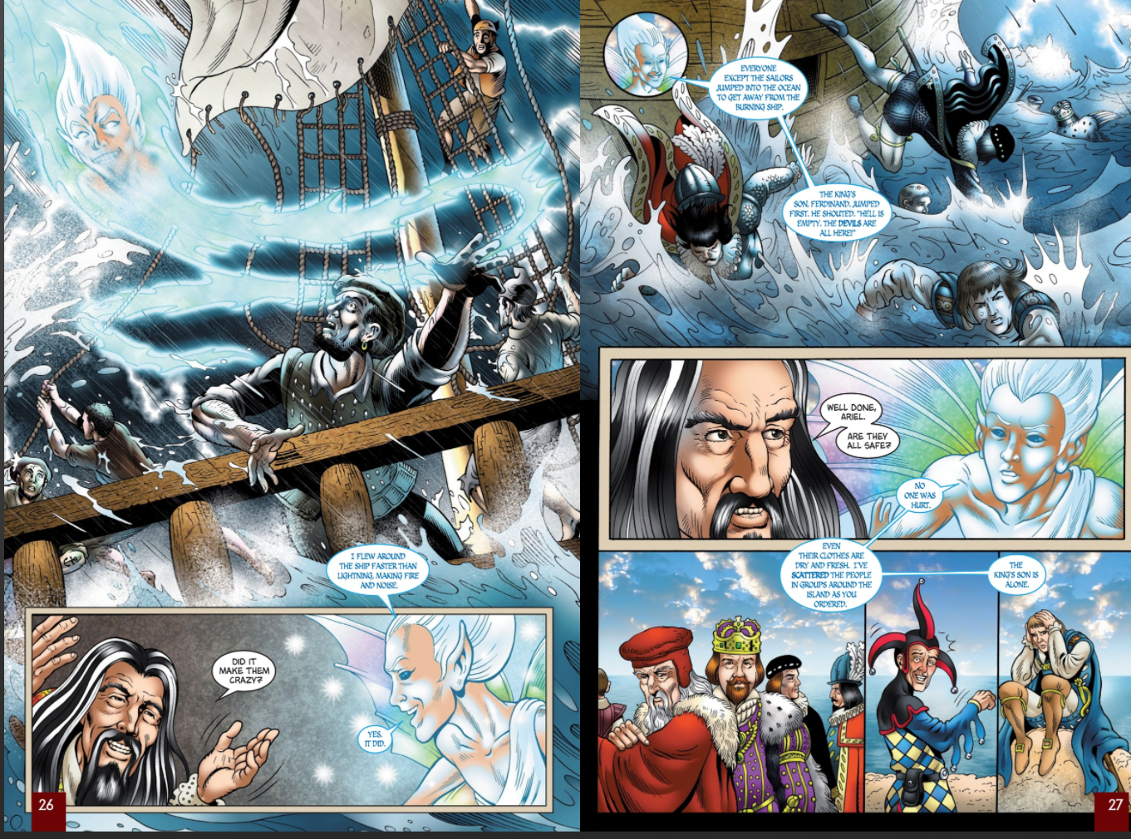
Setting the scene: “After telling this story, Prospero charms Miranda to sleep and then calls forth his familiar spirit Ariel, his chief magical agent. Prospero and Ariel’s discussion reveals that Ariel brought the tempest upon the ship and set fire to the mast. He then made sure that everyone got safely to the island, though they are now separated from each other into small groups.”

Early Modern Version | Modern Day Version
Enter ARIEL | ARIEL enters.
ARIEL  All hail, great master! Grave sir, hail! I come  To answer thy best pleasure, be ’t to fly,  To swim, to dive into the fire, to ride  On the curled clouds. To thy strong bidding, task  Ariel and all his quality. | ARIEL  Humble greetings, great master! Worthy sir, greetings! Your wish is my command, whatever you want. If you want me to fly, to swim, to jump into fire, to ride the clouds in the sky, Ariel will get right to the task.
PROSPERO  Hast thou, spirit,  Performed to point the tempest that I bade thee? | PROSPERO  Spirit, did you carry out the storm just as I ordered?
ARIEL  To every article.  I boarded the king’s ship. Now on the beak,  Now in the waist, the deck, in every cabin,  I flamed amazement. Sometime I’d divide,  And burn in many places. On the topmast,  The yards, and bowsprit would I flame distinctly,  Then meet and join. Jove’s lightning, the precursors  O' th' dreadful thunderclaps, more momentary  And sight-outrunning were not. The fire and cracks  Of sulfurous roaring the most mighty Neptune  Seem to besiege and make his bold waves tremble,  Yea, his dread trident shake. | ARIEL  Down to the last detail. I boarded the king’s ship, and in every corner of it, from the deck to the cabins, I made everyone astonished and terrified. Sometimes I appeared in many places at once. On the top sail and main mast I flamed in different spots, then I came together into a single flame. I flashed about faster than lightning. The fire and deafening cracks seemed to overwhelm even the god of the sea himself, making him tremble underwater.
PROSPERO  My brave spirit!  Who was so firm, so constant, that this coil  Would not infect his reason? | PROSPERO  Good spirit! Who could ever be so steady and strong that a disturbance like that wouldn’t make him crazy?
ARIEL  Not a soul  But felt a fever of the mad and played  Some tricks of desperation. All but mariners  Plunged in the foaming brine and quit the vessel,  Then all afire with me. The king’s son, Ferdinand,  With hair up-staring—then, like reeds, not hair—  Was the first man that leaped, cried, “Hell is empty  And all the devils are here.” | ARIEL  Everyone there got a little crazy and pulled some desperate stunts. Everyone except the sailors dove into the sea, leaving behind the ship that I had set on fire. The king’s son, Ferdinand, with his hair standing straight up—it looked like reeds, not hair—was the first person to jump, shouting, “Hell is empty, and all the devils are here!”
PROSPERO  Why, that’s my spirit!  But was not this nigh shore? | PROSPERO  Good job! But was this near the shore?
ARIEL  Close by, my master. | ARIEL  Very near, my master.
PROSPERO  But are they, Ariel, safe? | PROSPERO  But are they all safe, Ariel?
ARIEL  Not a hair perished.  On their sustaining garments not a blemish,  But fresher than before. And, as thou badest me,  In troops I have dispersed them 'bout the isle. | ARIEL  Nobody was hurt in the slightest. Even their clothes are unstained, and look fresher than before the storm. I’ve separated them into groups around the island, just as you ordered.

Shirley Jackson’s The Haunting of Hill House:

"No live organism can continue for long to exist sanely under conditions of absolute reality; even larks and katydids are supposed, by some, to dream. Hill House, not sane, stood by itself against its hills, holding darkness within; it had stood for eighty years and might stand for eighty more. Within, walls continued upright, bricks met neatly, floors were firm, and doors were sensibly shut; silence lay steadily against the wood and stone of Hill House, and whatever walked there, walked alone.”

The Turn of the Screw by Henry James
Plot

On Christmas Eve, an unnamed narrator and some of their friends are gathered around a fire. One of them, Douglas, reads a manuscript written by his sister's late governess. The manuscript tells the story of her hiring by a man who has become responsible for his young niece and nephew following the deaths of their parents. He lives mainly in London but also has a country house in Essex, Bly. The boy, Miles, is attending a boarding school, while his younger sister, Flora, is living in Bly, where she is cared for by Mrs. Grose, the housekeeper. Flora's uncle, the governess's new employer, is uninterested in raising the children and gives her full charge, explicitly stating that she is not to bother him with communications of any sort. The governess travels to Bly and begins her duties.
Miles returns from school for the summer just after a letter arrives from the headmaster stating that he has been expelled. Miles never speaks of the matter, and the governess is hesitant to raise the issue. She fears there is some horrible secret behind the expulsion, but is too charmed by the boy to want to press the issue. Soon after, around the grounds of the estate, the governess begins to see the figures of a man and woman whom she does not recognize. The figures come and go at will without being seen or challenged by other members of the household, and they seem to the governess to be supernatural. She learns from Mrs. Grose that the governess's predecessor, Miss Jessel, and another employee, Peter Quint, had had a close relationship. Before their deaths, Jessel and Quint spent much of their time with Flora and Miles, and the governess becomes convinced that the two children are aware of the ghosts' presence.
Without permission, Flora leaves the house while Miles is playing music for the governess. The governess notices Flora's absence and goes with Mrs. Grose in search of her. They find her on the shore of a nearby lake, and the governess is convinced that Flora has been talking to the ghost of Miss Jessel. When the governess finally confronts Flora, the girl denies seeing Miss Jessel, and asks not to see the new governess again. Mrs. Grose takes Flora away to her uncle, leaving the governess with Miles, who that night at last talks to her about his expulsion. The ghost of Quint appears to the governess at the window. The governess shields Miles, who attempts to see the ghost. The governess tells Miles he is no longer controlled by the ghost, and then finds that Miles has died in her arms.

Extract
Just as in the churchyard with Miles, the whole thing was upon us. Much as I had made of the fact that this name had never once, between us, been sounded, the quick, smitten glare with which the child’s face now received it fairly likened my breach of the silence to the smash of a pane of glass. It added to the interposing cry, as if to stay the blow, that Mrs. Grose, at the same instant, uttered over my violence—the shriek of a creature scared, or rather wounded, which, in turn, within a few seconds, was completed by a gasp of my own. I seized my colleague’s arm. “She’s there, she’s there!”
Miss Jessel stood before us on the opposite bank exactly as she had stood the other time, and I remember, strangely, as the first feeling now produced in me, my thrill of joy at having brought on a proof. She was there, and I was justified; she was there, and I was neither cruel nor mad. She was there for poor scared Mrs. Grose, but she was there most for Flora; and no moment of my monstrous time was perhaps so extraordinary as that in which I consciously threw out to her—with the sense that, pale and ravenous demon as she was, she would catch and understand it—an inarticulate message of gratitude. She rose erect on the spot my friend and I had lately quitted, and there was not, in all the long reach of her desire, an inch of her evil that fell short. This first vividness of vision and emotion were things of a few seconds, during which Mrs. Grose’s dazed blink across to where I pointed struck me as a sovereign sign that she too at last saw, just as it carried my own eyes precipitately to the child. The revelation then of the manner in which Flora was affected startled me, in truth, far more than it would have done to find her also merely agitated, for direct dismay was of course not what I had expected. Prepared and on her guard as our pursuit had actually made her, she would repress every betrayal; and I was therefore shaken, on the spot, by my first glimpse of the particular one for which I had not allowed. To see her, without a convulsion of her small pink face, not even feign to glance in the direction of the prodigy I announced, but only, instead of that, turn at me an expression of hard, still gravity, an expression absolutely new and unprecedented and that appeared to read and accuse and judge me—this was a stroke that somehow converted the little girl herself into the very presence that could make me quail. I quailed even though my certitude that she thoroughly saw was never greater than at that instant, and in the immediate need to defend myself I called it passionately to witness. “She’s there, you little unhappy thing—there, there, there, and you see her as well as you see me!” I had said shortly before to Mrs. Grose that she was not at these times a child, but an old, old woman, and that description of her could not have been more strikingly confirmed than in the way in which, for all answer to this, she simply showed me, without a concession, an admission, of her eyes, a countenance of deeper and deeper, of indeed suddenly quite fixed, reprobation. I was by this time—if I can put the whole thing at all together—more appalled at what I may properly call her manner than at anything else, though it was simultaneously with this that I became aware of having Mrs. Grose also, and very formidably, to reckon with. My elder companion, the next moment, at any rate, blotted out everything but her own flushed face and her loud, shocked protest, a burst of high disapproval. “What a dreadful turn, to be sure, miss! Where on earth do you see anything?”
I could only grasp her more quickly yet, for even while she spoke the hideous plain presence stood undimmed and undaunted. It had already lasted a minute, and it lasted while I continued, seizing my colleague, quite thrusting her at it and presenting her to it, to insist with my pointing hand. “You don’t see her exactly as we see?—you mean to say you don’t now—now? She’s as big as a blazing fire! Only look, dearest woman, look—!” She looked, even as I did, and gave me, with her deep groan of negation, repulsion, compassion—the mixture with her pity of her relief at her exemption—a sense, touching to me even then, that she would have backed me up if she could. I might well have needed that, for with this hard blow of the proof that her eyes were hopelessly sealed I felt my own situation horribly crumble, I felt—I saw—my livid predecessor press, from her position, on my defeat, and I was conscious, more than all, of what I should have from this instant to deal with in the astounding little attitude of Flora. Into this attitude Mrs. Grose immediately and violently entered, breaking, even while there pierced through my sense of ruin a prodigious private triumph, into breathless reassurance.

The Tempest – Act 1 Scene 2
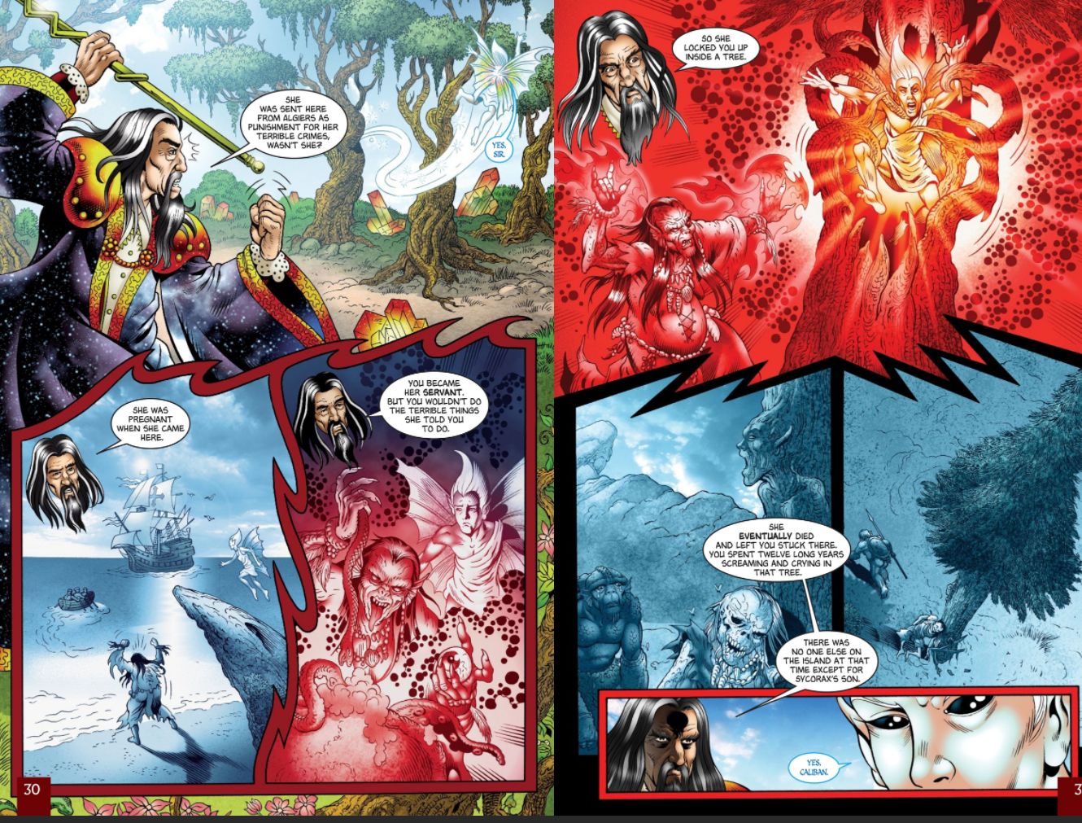
Setting the scene: “Ariel, who is a captive servant to Prospero, reminds his master that he has promised Ariel freedom a year early if he performs tasks such as these without complaint. Prospero chastises Ariel for protesting and reminds him of the horrible fate from which he was rescued. Before Prospero came to the island, a witch named Sycorax imprisoned Ariel in a tree. Sycorax died, leaving Ariel trapped until Prospero arrived and freed him. After Ariel assures Prospero that he knows his place, Prospero orders Ariel to take the shape of a sea nymph and make himself invisible to all but Prospero.”

Early Modern Version | Modern Day Version
PROSPERO  Dost thou forget  From what a torment I did free thee? | PROSPERO  Have you forgotten the torture I freed you from?
ARIEL  I do not, sir. | ARIEL  No, I don’t, sir.
PROSPERO  Thou liest, malignant thing! Hast thou forgot  The foul witch Sycorax, who with age and envy  Was grown into a hoop? Hast thou forgot her? | PROSPERO  You lie, you nasty, ungrateful thing! Have you forgotten the horrid witch Sycorax, stooped over with old age and ill will? Have you forgotten her?
ARIEL  No, sir. | ARIEL  No, sir.
PROSPERO  Thou hast. Where was she born? Speak. Tell me. | PROSPERO  You have. Where was she born? Speak. Tell me.
ARIEL  Sir, in Argier. | ARIEL  In Algiers, sir.
PROSPERO  This damned witch Sycorax,  For mischiefs manifold and sorceries terrible  To enter human hearing, from Argier,  Thou know’st, was banished. For one thing she did  They would not take her life. Is not this true? | PROSPERO  This damned witch Sycorax was kicked out of Algiers for various witching crimes too terrible for humans to hear about. But for one reason they refused to execute her. Isn’t that true?
ARIEL  Ay, sir. | ARIEL  Yes, sir.
PROSPERO  This blue-eyed hag was hither brought with child  And here was left by th' sailors. Thou, my slave,  As thou report’st thyself, wast then her servant.  And, for thou wast a spirit too delicate  To act her earthy and abhorred commands,  Refusing her grand hests, she did confine thee,  By help of her more potent ministers  Into a cloven pine, within which rift  Imprisoned thou didst painfully remain  A dozen years; within which space she died  And left thee there, where thou didst vent thy groans  As fast as mill wheels strike. Then was this island—  Save for the son that she did litter here,  A freckled whelp hag-born—not honored with  A human shape. | PROSPERO  This sunken-eyed hag was brought here pregnant and left by the sailors. You, my slave, were her servant at the time, as you admit yourself. You were too delicate to carry out her horrible orders, and you refused. In a fit of rage she locked you up in a hollow pine tree, with the help of her powerful assistants, and left you there for twelve years. During that time she died, and you were trapped, moaning and groaning. At that time there were no people here. This island was not honored with a human being—except for the son that Sycorax gave birth to here, a freckled baby born of an old hag.
ARIEL  Yes, Caliban, her son. | ARIEL  Yes, Caliban, her son.
PROSPERO  I arrived and heard thee, that made gape  The pine and let thee out. | PROSPERO  It was my magic that saved you when I arrived on the island and heard you, making the pine tree open and let you out.
ARIEL  I thank thee, master. | ARIEL  Thank you, master.
PROSPERO  If thou more murmur’st, I will rend an oak  And peg thee in his knotty entrails till  Thou hast howled away twelve winters. | PROSPERO  If you complain any more, I’ll split an oak tree and lock you up in it till you’ve howled for twelve years.

William Shakespeare’s Hamlet
Act 1 Scene 5
ORIGINAL TEXT | MODERN TEXT
Enter GHOST and HAMLET | The GHOST and HAMLET enter.
HAMLET  Where wilt thou lead me? Speak, I’ll go no further. | HAMLET  Where are you taking me? Speak. I’m not going any farther.
GHOST  Mark me. | GHOST  Listen to me.
HAMLET  I will. | HAMLET  I will.
GHOST  My hour is almost come  When I to sulfurous and tormenting flames  Must render up myself. | GHOST  The hour has almost come when I have to return to the horrible flames of purgatory.
HAMLET  Alas, poor ghost! | HAMLET  Ah, poor ghost!
GHOST  Pity me not, but lend thy serious hearing  To what I shall unfold. | GHOST  Don’t pity me. Just listen carefully to what I have to tell you.
HAMLET  Speak. I am bound to hear. | HAMLET  Speak. I’m ready to hear you.
GHOST  So art thou to revenge when thou shalt hear. | GHOST  You must be ready for revenge, too, when you hear me out.
HAMLET  What? | HAMLET  What?
GHOST  I am thy father’s spirit,  Doomed for a certain term to walk the night  And for the day confined to fast in fires,  Till the foul crimes done in my days of nature  Are burnt and purged away. But that I am forbid  To tell the secrets of my prison house,  I could a tale unfold whose lightest word  Would harrow up thy soul, freeze thy young blood, | GHOST  I’m the ghost of your father, doomed for a certain period of time to walk the earth at night, while during the day I’m trapped in the fires of purgatory until I’ve done penance for my past sins. If I weren’t forbidden to tell you the secrets of purgatory, I could tell you stories that would slice through your soul, freeze your blood,
Freedom vs Confinement
Small question 4:
Why are stories that are set on a deserted island interesting?

The Tempest – Act 1 Scene 2
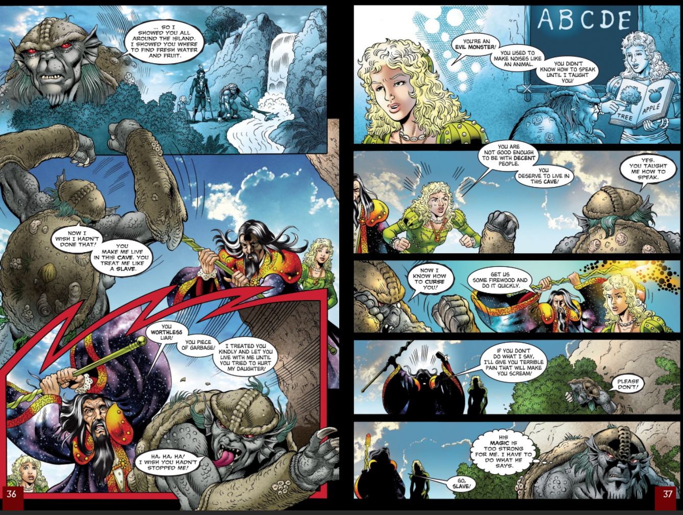
Setting the scene: “Miranda awakens from her sleep, and she and Prospero go to visit Caliban, Prospero’s servant and the son of the dead Sycorax. Caliban curses Prospero, and Prospero and Miranda berate him for being ungrateful for what they have given and taught him. Prospero sends Caliban to fetch firewood.”

Early Modern Version | Modern Day Version
PROSPERO  (to CALIBAN) Thou poisonous slave, got by the devil himself  Upon thy wicked dam, come forth! | PROSPERO  (to CALIBAN) You horrible slave, with a wicked hag for a mother and the devil himself for a father, come out!
Enter CALIBAN | CALIBAN enters.
CALIBAN  A southwest blow on ye  And blister you all o'er! | CALIBAN  May a hot southwest wind blow on you and cover you with blisters all over.
CALIBAN  I must eat my dinner.  This island’s mine, by Sycorax my mother,  Which thou takest from me. When thou camest first,  Thou strok’st me and made much of me, wouldst give me  Water with berries in ’t, and teach me how  To name the bigger light, and how the less,  That burn by day and night. And then I loved thee  And showed thee all the qualities o' th' isle,  The fresh springs, brine pits, barren place and fertile.  Cursed be I that did so! | CALIBAN  I have to eat my dinner now. This island belongs to me because Sycorax, my mother, left it to me. But you’ve taken it from me. When you first got here, you petted me and took care of me, you would give me water with berries in it, and you taught me the names for the sun and the moon, the big light and the smaller light that burn in daytime and nighttime. I loved you back then. I showed you all the features of the island, the freshwater springs, the saltwater pits, the barren places and the fertile ones. I curse myself for doing that!
MIRANDA  Abhorrèd slave,  Which any print of goodness wilt not take,  Being capable of all ill! I pitied thee,  Took pains to make thee speak, taught thee each hour  One thing or other. When thou didst not, savage,  Know thine own meaning, but wouldst gabble like  A thing most brutish, I endowed thy purposes  With words that made them known. | MIRANDA  You horrid slave, you can’t be trained to be good, and you’re capable of anything evil! I pitied you, worked hard to teach you to speak, and taught you some new thing practically every hour. When you didn’t know what you were saying, and were babbling like an animal, I helped you find words to make your point understandable.
CALIBAN  You taught me language, and my profit on ’t  Is I know how to curse. The red plague rid you  For learning me your language! | CALIBAN  You taught me language, and all I can do with it is curse. Damn you for teaching me your language!
PROSPERO  Hag-seed, hence!  If thou neglect’st or dost unwillingly  What I command, I’ll rack thee with old cramps,  Fill all thy bones with aches, make thee roar  That beasts shall tremble at thy din. | PROSPERO  Get out of here, you son of a bitch! If you neglect my orders or do them grudgingly, I’ll double you up with pains and cramps, and make all your bones ache, and make you scream so loud that the wild animals will tremble when they hear you.
CALIBAN  No, pray thee.  (aside) I must obey. His art is of such power,  It would control my dam’s god, Setebos,  And make a vassal of him. | CALIBAN  No, please. (to himself) I have to obey. He’s got such strong magic powers that he could conquer and enslave the god, Setebos, that my mother used to worship.
PROSPERO  So, slave, hence! | PROSPERO  Go then, slave.

Things Fall Apart – Chinua Achebe

Synopsis - It depicts pre-colonial life in the southeastern part of Nigeria and the arrival of Europeans during the late 19th century. It is seen as the archetypal modern African novel in English, and one of the first to receive global critical acclaim. The novel follows the life of Okonkwo, an Igbo ("Ibo" in the novel) man and local wrestling champion in the fictional Nigerian clan of Umuofia. The work is split into three parts, with the first describing his family, personal history, and the customs and society of the Igbo, and the second and third sections introducing the influence of European colonialism and Christian missionaries on Okonkwo, his family, and the wider Igbo community.
Extract from Chapter 20
Umuofia had indeed changed during the seven years Okonkwo had been in exile. The church had come and led many astray. Not only the low-born and the outcast but sometimes a worthy man had joined it. Such a man was Ogbuefi Ugonna, who had taken two titles, and who like a madman had cut the anklet of his titles and cast it away to join the Christians. The white missionary was very proud of him and he was one of the first men in Umuofia to receive the sacrament of Holy Communion, or Holy Feast as it was called in lbo. Ogbuefi Ugonna had thought of the Feast in terms of eating and drinking, only more holy than the village variety. He had therefore put his drinking-horn into his goatskin bag for the occasion.
But apart from the church, the white men had also brought a government. They had built a court where the District Commissioner judged cases in ignorance. He had court messengers who brought men to him for trial. Many of these messengers came from Umuru on the bank of the' Great River, where the white men first came many years before and where they had built the center of their religion and trade and government. These court messengers were greatly hated in Umuofia because they were foreigners and also arrogant and high-handed. They were called kotma, and because of their ash-colored shorts they earned the additional name of Ashy Buttocks. They guarded the prison, which was full of men who had offended against the white man's law. […] They were beaten in the prison by the 6tma and made to work every morning clearing the government compound and fetching wood for the white Commissioner and the court messengers. Some of these prisoners were men of title who should be above such mean occupation. They were grieved by the indignity and mourned for their neglected farms. As they cut grass in the morning the younger men sang in time with the strokes of their machetes:
"Kotma of the ash buttocks,
He is fit to be a slave.
The white man has no sense,
He is fit to be a slave."
The court messengers did not like to be called Ashy Buttocks, and they beat the men. But the song spread in Umuofia.
Okonkwo's head was bowed in sadness as Obierika told him these things.
"Perhaps I have been away too long," Okonkwo said, almost to himself. "But I cannot understand these things you tell me. What is it that has happened to our people? Why have they lost the power to fight?"
"Have you not heard how the white man wiped-out Abame?" asked Obierika. I have heard," said Okonkwo.
"But I have also heard that Abame people were weak and foolish. Why did they not fight back? Had they no guns and machetes? We would be cowards to compare ourselves with the men of Abame. Their fathers had never dared to stand before our ancestors. We must fight these men and drive them from the land."
"It is already too late," said Obierika sadly. "Our own men and our sons have joined the ranks of the stranger. They have joined his religion and they help to uphold his government. If we should try to drive out the white men in Umuofia we should find it easy. There are only two of them. But what of our own people who are following their way and have been given power? They would go to Umuru and bring the soldiers, and we would be like Abame." He paused for a long time and then said: "I told you on my last visit to Mbanta how they hanged Aneto."
"What has happened to that piece of land in dispute" asked Okonkwo.
"The white man's court has decided that it should belong to Nnama's family, who had, given much money to the white man's messengers and interpreter."
"Does the white man understand our custom about land?"
"How can he when he does not even speak our tongue? But he says that our customs are bad; and our own brothers who have taken up his religion also say that our customs are bad. How do you think we can fight when our own brothers have turned against us? The white man is very clever. He came quietly and peaceably with his religion. We were amused at his foolishness and allowed him to stay. Now he has won our brothers, and our clan can no longer act like one. He has put a knife on the things that held us together and we have fallen apart."
"How did they get hold of Aneto to hang him?" asked Okonkwo.
"When he killed Oduche in the fight over the land, he fled to Aninta to escape the wrath of the earth. This was about eight days after the fight, because Oduche had not died immediately from his wounds. It was on the seventh day that he died. But everybody knew that he was going to die and Aneto got his belongings together in readiness to flee. But the Christians had told the white man about the accident, and he sent his Kotma to catch Aneto. He was imprisoned with all the leaders of his family. In the end Oduche died and Aneto was taken to Umuru and hanged. The other people were released, but even now they have not found the mouth with which to tell of their suffering,"
The two men sat in silence for a long while afterwards.
Colonisation of America Timeline
The Tempest – Act 2 Scene 2
Setting the scene: “Caliban, meanwhile, is hauling wood for Prospero when he sees Trinculo and thinks he is a spirit sent by Prospero to torment him. He lies down and hides under his cloak. A storm is brewing, and Trinculo, curious about but undeterred by Caliban’s strange appearance and smell, crawls under the cloak with him. Stephano, drunk and singing, comes along and stumbles upon the bizarre spectacle of Caliban and Trinculo huddled under the cloak. Caliban, hearing the singing, cries out that he will work faster so long as the “spirits” leave him alone. Stephano decides that this monster requires liquor and attempts to get Caliban to drink. Trinculo recognizes his friend Stephano and calls out to him. Soon the three are sitting up together and drinking. Caliban quickly becomes an enthusiastic drinker, and begins to sing.”
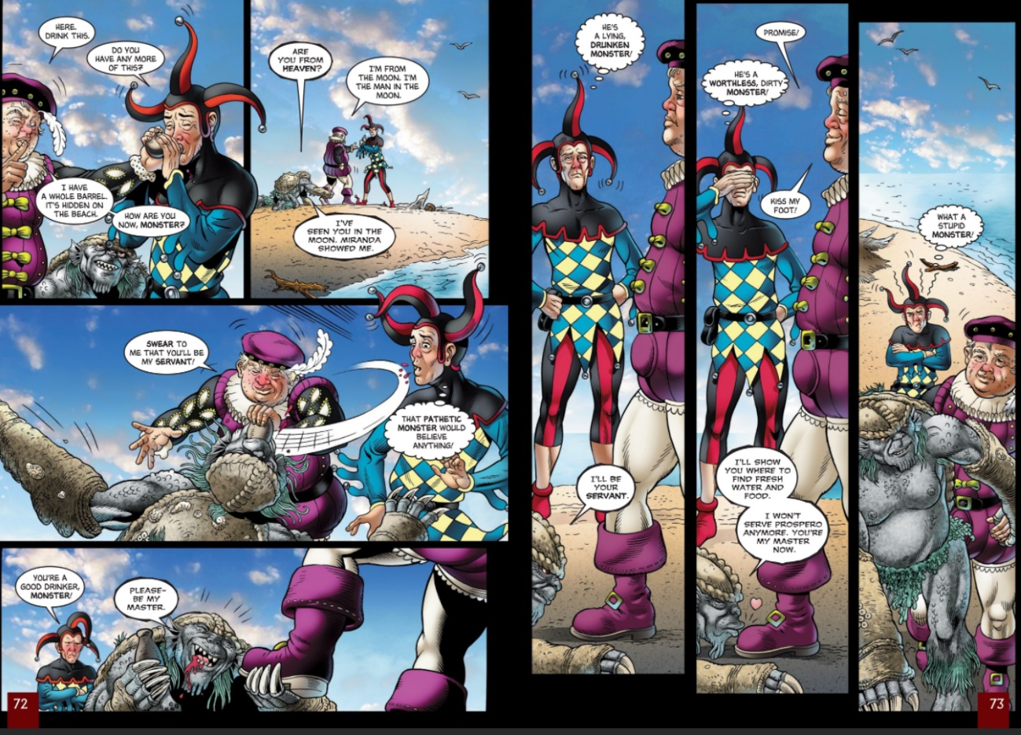
Early Modern Version | Modern Day Version
Enter CALIBAN with a burden of wood A noise of thunder heard | CALIBAN enters with a load of wood. A noise of thunder is heard.
Enter TRINCULO | TRINCULO enters.
What have we here? A man or a fish? Dead or alive? A fish. He smells like a fish, a very ancient and fish-like smell, a kind of not-of-the-newest poor-john. A strange fish! | What do we have here, a man or a fish? Whew, he stinks like a fish—an old salted fish, not a fresh-caught one. A strange fish.
Enter STEPHANO, singing and carrying a bottle of beer | STEPHANO enters, singing and carrying a bottle of beer
STEPHANO  (sings)  I shall no more to sea, to sea,  Here shall I die ashore—  The master, the swabber, the boatswain, and I,  The gunner and his mate  Loved Mall, Meg, and Marian, and Margery,  But none of us cared for Kate.  For she had a tongue with a tang, | STEPHANO  (sings)  I’ll never go to sea again,  I’ll die here on shore—  The master, the deck-washer, the boatswain, and I,  The gunman and his friend,  We loved Moll, Meg, Marian, and Margery  But none of us cared for Kate.  Kate had a gutter mouth,
CALIBAN  The spirit torments me. Oh! | CALIBAN  The spirit is torturing me. Oh!
STEPHANO  This is some monster of the isle with four legs who hath got, as I take it, an ague. Where the devil should he learn our language? | STEPHANO  This is some monster of the island, with four legs, who seems to me to have some kind of ache. How the hell does he know our language?
CALIBAN  Do not torment me, prithee. I’ll bring my wood home faster. | CALIBAN  Don’t hurt me, please. I promise I’ll carry the wood faster.
STEPHANO  He’s in his fit now and does not talk after the wisest. He shall taste of my bottle. If he have never drunk wine afore, it will go near to remove his fit. | STEPHANO  He’s having a fit and talking nonsense. I’ll give him some liquor. If he’s never drunk it before, it’ll help soothe his fever.
CALIBAN  (aside) These be fine things, an if they be not sprites. That’s a brave god and bears celestial liquor. I will kneel to him.  Hast thou not dropped from heaven? | CALIBAN  (to himself) These are beautiful creatures, if they’re not spirits. He’s a good god, who brings liquor from the heavens. I will worship him.  You come from heaven, don’t you?
CALIBAN drinks | CALIBAN drinks.
TRINCULO  By this good light, this is a very shallow monster. I afeard of him! A very weak monster. A most poor credulous monster | TRINCULO  When you get a good look at him, you see he’s not much of a monster. I can’t believe I was scared of him! A pretty pathetic monster. What a poor, gullible monster
CALIBAN  (to STEPHANO) I’ll show thee every fertile inch o' th' island.  And I will kiss thy foot. I prithee, be my god.  I’ll swear myself thy subject. | CALIBAN  (to STEPHANO) I’ll show you every inch of the island, and I’ll kiss your feet. I beg you, please be my god. I’ll vow to be your faithful subject.
STEPHANO  Come on then. Down, and swear. | STEPHANO  Come on, then. Get down and swear it.
CALIBAN  90(sings)  No more dams I’ll make for fish,  Nor fetch in firing  At requiring,  Nor scrape trencher, nor wash dish.  ’Ban, ‘Ban, Ca-caliban  Has a new master. Get a new man.  Freedom, high-day, high-day, freedom, freedom, high-day, freedom! | CALIBAN  (sings)  I won’t build you any more dams to catch fish,  Or fetch you firewood when you order me to,  Or clean the plates, or wash dishes.  ’Ban, ‘ban, Ca-caliban  Has a new master. So get a new servant.  Freedom, what a wonderful day, wonderful day, freedom, freedom, wonderful day, freedom!

Lord of the Flies by William Golding

Synopsis - The book focuses on a group of British boys stranded on an uninhabited island and their disastrous attempt to govern themselves. Themes include the tension between groupthink and individuality, between rational and emotional reactions, and between morality and immorality.
Extract - The shore was fledged with palm trees. These stood or leaned or reclined against the light and their green feathers were a hundred feet up in the air. The ground beneath them was a bank covered with coarse grass, torn everywhere by the upheavals of fallen trees, scattered with decaying coconuts and palm saplings. Behind this was the darkness of the forest proper and the open space of the scar. Ralph stood, one hand against a grey trunk, and screwed up his eyes against the shimmering water. Out there, perhaps a mile away, the white surf flinked on a coral reef, and beyond that the open sea was dark blue. Within the irregular arc of coral the lagoon was still as a mountain lake—blue of all shades and shadowy green and purple. The beach between the palm terrace and the water was a thin stick, endless apparently, for to Ralph’s left the perspectives of palm and beach and water drew to a point at infinity; and always, almost visible, was the heat. He jumped down from the terrace. The sand was thick over his black shoes and the heat hit him. He became conscious of the weight of clothes, kicked his shoes off fiercely and ripped off each stocking with its elastic garter in a single movement. Then he leapt back on the terrace, pulled off his shirt, and stood there among the skull-like coconuts with green shadows from the palms and the forest sliding over his skin. He undid the snake-clasp of his belt, lugged off his shorts and pants, and stood there naked, looking at the dazzling beach and the water.
[…]
Here the beach was interrupted abruptly by the square motif of the landscape; a great platform of pink granite thrust up uncompromisingly through forest and terrace and sand and lagoon to make a raised jetty four feet high. The top of this was covered with a thin layer of soil and coarse grass and shaded with young palm trees. There was not enough soil for them to grow to any height and when they reached perhaps twenty feet they fell and dried, forming a criss-cross pattern of trunks, very convenient to sit on. The palms that still stood made a green roof, covered on the underside with a quivering tangle of reflections from the lagoon. Ralph hauled himself onto this platform, noted the coolness and shade, shut one eye, and decided that the shadows on his body were really green. He picked his way to the seaward edge of the platform and stood looking down into the water. It was clear to the bottom and bright with the efflorescence of tropical weed and coral. A school of tiny, glittering fish flicked hither and thither. Ralph spoke to himself, sounding the bass strings of delight.

Love and Commitment
Small question 5:
How are different versions of love portrayed in The Tempest?

The Tempest – Act 3 Scene 1
Setting the scene: “Prospero puts Ferdinand to work hauling wood. Ferdinand finds his labor pleasant because it is for Miranda’s sake. Miranda, thinking that her father is asleep, tells Ferdinand to take a break. The two flirt with one another. Miranda proposes marriage, and Ferdinand accepts.”
Early Modern Version | Modern Day Version
MIRANDA  You look wearily. | MIRANDA  You look tired.
FERDINAND  No, noble mistress. 'Tis fresh morning with me  When you are by at night. I do beseech you—  Chiefly that I might set it in my prayers—  What is your name? | FERDINAND  No, noble mistress, I’m as fresh as morning when you’re near me, even at night. I beg you to tell me your name so I can use it in my prayers.
MIRANDA  Miranda.—O my father,  I have broke your hest to say so! | MIRANDA  Miranda.—Oh father, I’ve disobeyed you by telling him that!
FERDINAND  Admired Miranda!  Indeed the top of admiration, worth  What’s dearest to th' world! | FERDINAND  Miranda—the very name means “admired!” You are indeed admired, more than anything else in the world!
O you,  So perfect and so peerless, are created  Of every creature’s best. | You’re perfect, without a rival in the world, made up of the best qualities of every creature.
MIRANDA  I do not know  One of my sex, no woman’s face remember—  Save, from my glass, mine own. Nor have I seen  More that I may call men than you, good friend,  And my dear father. How features are abroad  I am skill-less of, but, by my modesty,  The jewel in my dower, I would not wish  Any companion in the world but you, | MIRANDA  I’ve never known any woman or seen a woman’s face—except my own in the mirror. And I’ve never met any men besides you and my father. I have no idea what people look like in other places, but I swear by my modesty, which I value above everything else, that I’d never want any companion in the world but you.
FERDINAND  I am in my condition  A prince, Miranda—I do think, a king;  I would, not so! | FERDINAND  I’m a prince by birth, Miranda—maybe even a king now; though I wish I weren’t.
MIRANDA  Do you love me? | MIRANDA  Do you love me?
FERDINAND  O heaven, O earth, bear witness to this sound  And crown what I profess with kind event | FERDINAND  Oh heaven, oh earth, witness what I’m about to say, and reward me if I tell the truth!
If I speak true!  I beyond all limit of what else i' th' world  Do love, prize, honor you. | More than anything else in the world, I love you, value you, and honor you.
MIRANDA  I am a fool  To weep at what I am glad of. | MIRANDA  Look at me crying—what a fool I am to cry at what makes me happy.
FERDINAND  Wherefore weep you? | FERDINAND  Why are you crying?
MIRANDA  At mine unworthiness, that dare not offer  What I desire to give, and much less take  80What I shall die to want.  I am your wife if you will marry me.  If not, I’ll die your maid. | MIRANDA  I’m crying at how unworthy I am to give you what I want to give you and to take what I’m dying to have. I’ll be your wife if you’ll have me. Otherwise, I’ll die a virgin, devoted to you.
FERDINAND  My mistress, dearest, and I thus humble ever. | FERDINAND  You’ll be my wife, dearest, and I’ll serve you forever.
MIRANDA  My husband, then? | MIRANDA  Will you be my husband, then?
FERDINAND  Ay, with a heart as willing  As bondage e'er of freedom. Here’s my hand. | FERDINAND  Yes, with a heart more eager to bear a husband’s responsibilities than a slave ever wanted freedom. Take my hand, darling.
Then after this scene: Stephano, Trinculo, and Caliban are now drunk and raucous and are made all the more so by Ariel, who comes to them invisibly and provokes them to fight with one another by impersonating their voices and taunting them. Caliban grows more and more fervent in his boasts that he knows how to kill Prospero. He even tells Stephano that he can bring him to where Prospero is sleeping. He proposes that they kill Prospero, take his daughter, and set Stephano up as king of the island. Stephano thinks this a good plan, and the three prepare to set off to find Prospero. They are distracted, however, by the sound of music that Ariel plays on his flute and tabor-drum, and they decide to follow this music before executing their plot.

Pride and Prejudice: Love and Marriage Theme

Though, marriage is the end of Jane Austen’s novel, yet it evolves more than the conclusion of a simple love story. There is a depth, variety and seriousness in Jane’s treatment of these topics.
Marriage was an important social concern in Jane Austen’s time and she was fully aware of the disadvantages of remaining single. In a letter to her niece, Fanny Knight, she wrote:
Single women have a dreadful propensity for being poor – which is a very strong argument in favour of matrimony. The only option for unmarried woman in Jane Austen’s time was to care for someone else’s children as Jane Austen herself did; as there were no outlets for women.The novels of Jane Austen’s – especially “Pride and Prejudice” – dramatize the economic inequality of women, showing how women had to marry undesirable mates in order to gain some financial security.
The theme of love and marriage is one of the major themes in “Pride and Prejudice”. Through five marriages, Jane Austen defines good and bad reasons for marriage. Charlotte – Collins, Lydia – Wickham, Jane – Bingley and Elizabeth – Darcy are the four newly-weds. The old marriage is that of Mr. and Mrs. Bennet.
Mrs. and Mr. Bennet are poles apart in their natural attitude. Mr. Bennet is sharp and witty. Mrs. Bennet is vulgar and discreet. Together they constitute a very ill-matched couple.
Her father, captivated by youth and beauty … had married a woman whose weak understanding and liberal mind had very early in their marriage put an end to all real affection for her.
Mr. Bennet married for beauty. Soon he realized that Mrs. Bennet, due to her intellectual bankruptcy and narrow vision, would not make him an ideal wife. Mr. and Mrs. Bennet never enjoyed the marital bliss of emotional and intellectual understanding. The gulf between them had widened. Mr. Bennet becomes lazy and irresponsible and an odd mixture of ‘sarcastic humour, and caprice’. He mocks Mrs. Bennet and exposes her to the scorn of their five daughters. The disadvantages of such marriage attend the daughters also. Elizabeth and Jane become what they are almost. Mary becomes a vain. Lydia grows into a selfish and deceitful flirt who elopes with a selfish and corrupt rake. The stupid and weak-spirited Kitty follows Lydia’s example and flirts with the military officers.
Charlotte and Collins are the first to get married. Collins, after, having a very good house and very sufficient income, intends to marry. He visits the Bennetts to choose a wife among the Bennet girls. He sets out in detail his reasons for marriage: First … it a right thing for every clergyman in easy circumstances to set the example of matrimony in his parish. Secondly … it will add very greatly to my happiness, and thirdly … that is particular advice and recommendation of the very noble lady whom I have the honour of calling patroness.
Mr. Collins does not have any respect and affection for the girl he intends to marry. So, Elizabeth declines the proposal. Collins shifts contentedly to Charlotte who is herself eager to accept his proposal. Mr. Collins … was neither sensible nor agreeable … But still he would be her husband … marriage had always been her object; it was the only honourable provision for well-educated young women of small fortune. Obviously Charlotte also does not think of love. She accepts Mr. Collins under economic pressure, knowing that she is going to marry an ass. Elizabeth is shocked at Charlotte’s engagement. Charlotte defends herself by saying:
I am not romantic you know. I never was. I ask only a comfortable home.
The next to be married are Wickham and Lydia. They elope before they get married. Compatibility and understanding are once again absent. Lydia is captivated by the external glamour of Wickham’s personality. She thinks, she is in love with him but she is only infatuated. They were always moving from place to place in quest of a cheep situation, and always spending more then they ought. His affection for her soon sunk into indifference; hers lasted a little longer.
Jane and Bingley are sincerely in love with each other. Between them exists a great emotional compatibility. By nature, both are sweet and gentle, free from malice, ill will, affectation and duplicity, calm, unsuspecting, simple and willing to forgive readily. There is every likelihood that they will lead a happy married life. Still, their marriage is timidly weak. Bingley is too weak-willed that in spite of loving Jane deeply, he does not take any initiative. Their temperamental harmony lacks the strengthening support of intellectual understanding and maturity. Still they will be happy because Bingley is too good to offend consciously and Jane is too good not to forgive even any offense.
Elizabeth marries last and most desirably. When Darcy makes his first proposal, he had no doubts of a favourable answer. He acted as if he was offering prize which no sensible woman can refuse. All the other characters believe Darcy to be a prize and that Elizabeth is falling for his wealth. Elizabeth rejects his proposal but accepts it for the second time.
Elizabeth and Darcy begin with prejudices and gradually move towards understanding. Elizabeth helps Darcy to shed his pride and be really the gentleman. Darcy in turn acts nobly and generously to win her love. Mutual affection and regards developed between them that form the basis of a sound marriage.
It was a union that must have been to the advantage of both.
Elizabeth has to assure that she loves and respects Darcy. Love and respect count most in a marital union, and having secured both, Elizabeth does not make any false or exaggerated statement when she says half-mockingly:
It is settled between us already that we are to be the happiest couple in the world.
Thus it is true that the chief preoccupation of Jane Austen’s heroines is getting married and life is a matrimonial game as women in her times had no other option of business or profession open to them. However, marriage is not treated merely as a romantic end. Rather it is dealt with a depth variety and seriousness to highlight ‘good’ marriage based on mutual understanding, love, good sense and respect.

The Spectacle
Small question 6:
How can a scene hold an audience’s attention?

The Tempest – Act 3 Scene 2
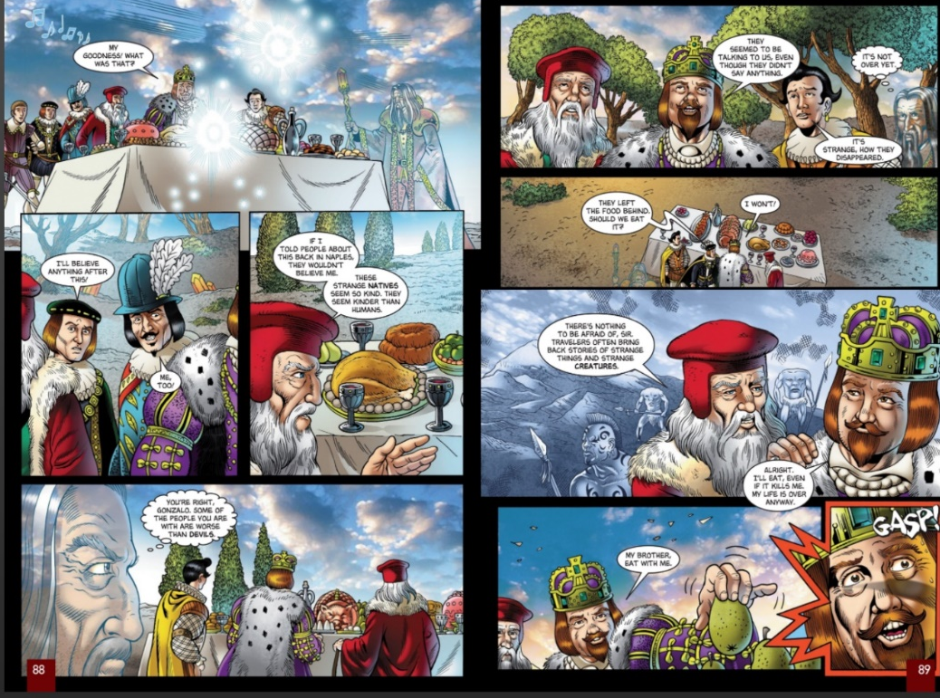
Setting the scene: “Alonso, Gonzalo, Sebastian, and Antonio grow weary from traveling and pause to rest. Antonio and Sebastian secretly plot to take advantage of Alonso and Gonzalo’s exhaustion, deciding to kill them in the evening. Prospero, probably on the balcony of the stage and invisible to the men, causes a banquet to be set out by strangely shaped spirits. As the men prepare to eat, Ariel appears like a harpy and causes the banquet to vanish. He then accuses the men of supplanting Prospero and says that it was for this sin that Alonso’s son, Ferdinand, has been taken. He vanishes, leaving Alonso feeling vexed and guilty.”

When Prospero left them, he called his spirit Ariel, who quickly appeared before him, eager to relate what he had done with Prospero’s brother and the king of Naples. Ariel said he had left them almost out of their senses with fear, at the strange things he had caused them to see and hear. When fatigued with wandering about, and famished for want of food, he had suddenly set before them a delicious banquet, and then, just as they were going to eat, he appeared visible before them in the shape of a harpy, a voracious monster with wings, and the feast vanished away. Then, to their utter amazement, this seeming harpy spoke to them, reminding them of their cruelty in driving Prospero from his dukedom, and leaving him and his infant daughter to perish in the sea; saying, that for this cause these terrors were suffered to afflict them.
The king of Naples, and Antonio the false brother, repented the injustice they had done to Prospero; and Ariel told his master he was certain their penitence was sincere, and that he, though a spirit, could not but pity them.
“Then bring them hither, Ariel,” said Prospero: “if you, who are but a spirit, feel for their distress, shall not I, who am a human being like themselves, have compassion on them? Bring them, quickly, my dainty Ariel.”

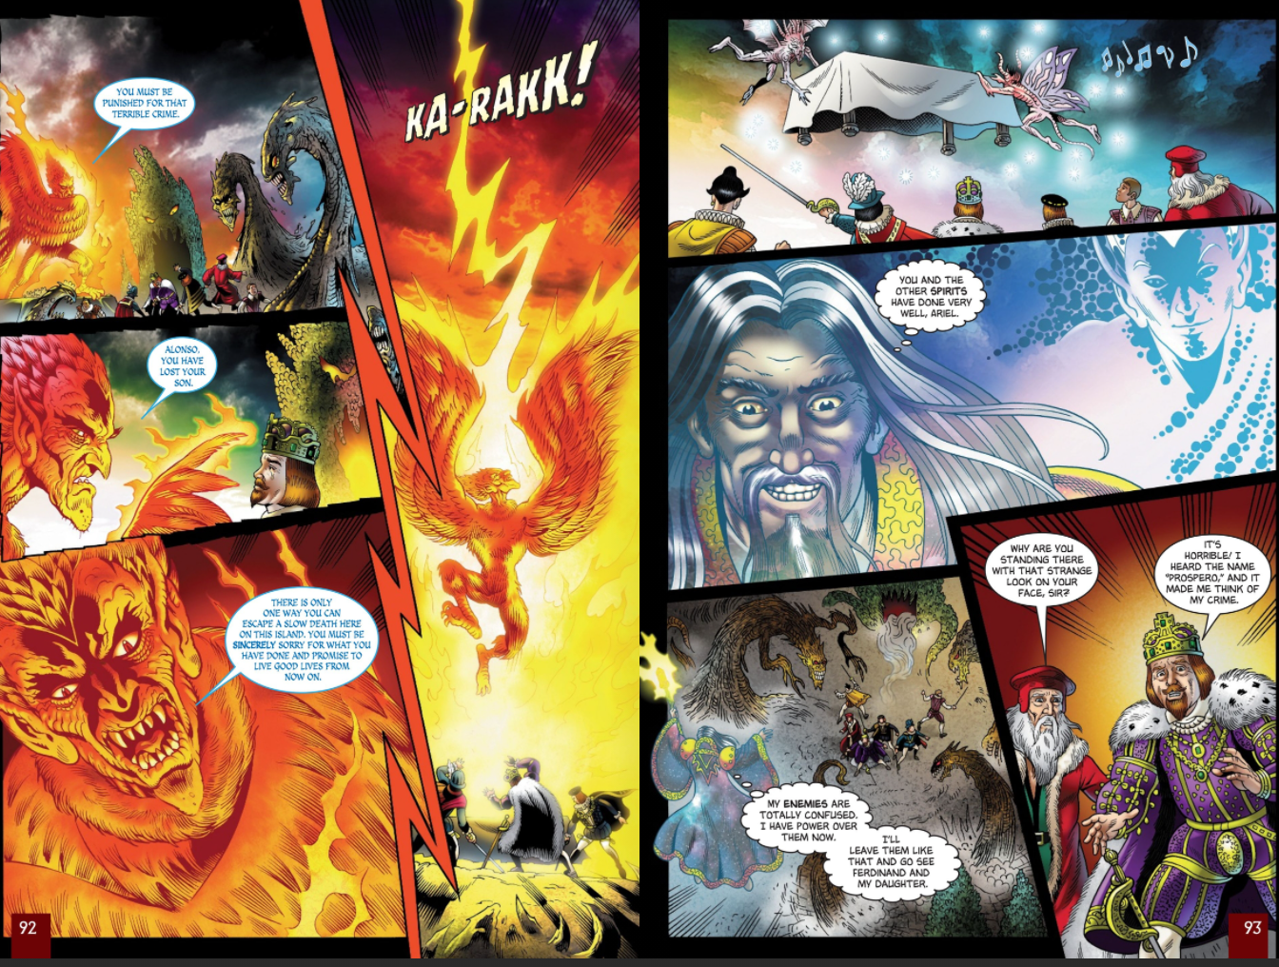

Olympic opening ceremony: Peter Bradshaw's review

It didn't make a bit of sense, but what a thrilling spectacle and what fun
Danny Boyle has just made the biggest, maddest, weirdest, most heartfelt and lovable dream sequence in British cinema history. Heaven knows, hopes were not high after our sheepish "handover" performance in Beijing in 2008; we thought we would never match the Chinese and many of us were getting ready to excuse the anticipated cockups and catastrophes as proof of our supposedly superior democratic tolerance.
But Boyle's opening ceremony was the equal of Beijing and more.
He had the spectacle – chiefly, an inspired vision of the five Olympic rings being forged by the workers of the industrial revolution.
But he also had jokes and laughs; he had narrative, of a cheerfully loopy kind, with some anarchic fun, and cheeky comic turns from Daniel Craig, Rowan Atkinson and the Queen. Sometimes it looked like a 21st-century version of an Elizabethan pageant. Sometimes it looked like a seaside summer special on amyl nitrate. But it always looked great.
The Olympic opening ceremony is a very cinematic tradition. As a genre, it was pretty much invented by Leni Riefenstahl for the 1936 Berlin Games, and then given a dose of Hollywood razzmatazz for LA in 1984, with choreography inspired by the song 'n' dance routines that kick off the Academy Award ceremony. Both these influences are very serious. Boyle corrected this, and gave the ceremony two things I never believed could co-exist in a sports arena: a sense of humour and a sense of wonder. To begin with, his guiding force seemed to be Terry Gilliam, or maybe Peter Jackson. A surreal vision of bucolic Britain unfolded in a Teletubby-shire. Then Sir Kenneth Branagh came on as a glamorous Isambard Kingdom Brunel, declaimed Caliban's "isle is full of noises" speech from The Tempest with a positive spin on the word "dream". And the industrial revolution swept everything away.
The hyperreal greensward vanished, as if by magic, and the 19th century arrived, giving way bizarrely but entertainingly to Sgt Pepper's Lonely Hearts Club band. There was a glorious tribute to the NHS, whose care and attention to child patients was elided sentimentally but persuasively with the glories of great children's literature and its scary villains. JK Rowling made a stylish appearance. But the evening took off like a rocket with a romantic fantasia, riffing on the eternal Saturday night, social media, boy meets girl. The director shyly gave us an allusion to his own film Trainspotting, along with flashes of Bill Forsyth's Gregory's Girl and Ken Loach's Kes – and many more. It didn't make a bit of sense, but what a thrilling spectacle and what fun. This could be Danny Boyle's 3D multimedia masterpiece.

Compassion and Forgiveness
Small question 7:
What methods and language devices can a writer use to create a good ending for their story?

The Tempest – Act 5 Scene 1
Setting the scene: “Prospero uses Ariel to bring Alonso and the others before him. He then sends Ariel to bring the Boatswain and the mariners from where they sleep on the wrecked ship. Prospero confronts Alonso, Antonio, and Sebastian with their treachery, but tells them that he forgives them.”
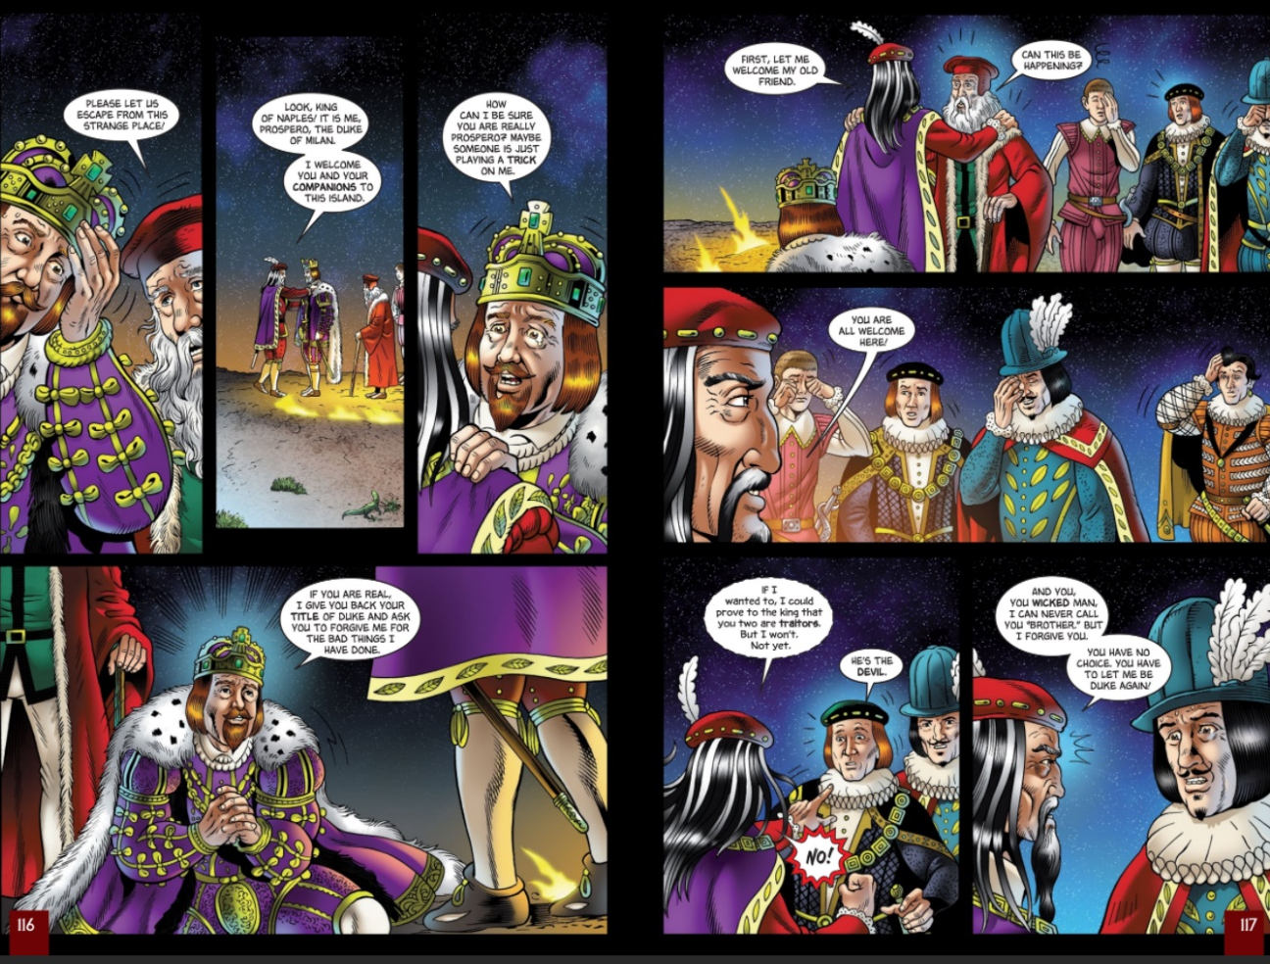
Ariel soon returned with the king, Antonio, and old Gonzalo in their train, who had followed him, wondering at the wild music he played in the air to draw them on to his master’s presence. This Gonzalo was the same who had so kindly provided Prospero formerly with books and provisions, when his wicked brother left him, as he thought, to perish in an open boat in the sea.
Grief and terror had so stupefied their senses, that they did not know Prospero. He first discovered himself to the good old Gonzalo, calling him the preserver of his life; and then his brother and the king knew that he was the injured Prospero.
Antonio with tears, and sad words of sorrow and true repentance, implored his brother’s forgiveness, and the king expressed his sincere remorse for having assisted Antonio to depose his brother: and Prospero forgave them and, upon their engaging to restore his dukedom, he said to the king of Naples, “I have a gift in store for you too;” and opening a door, showed him his son Ferdinand playing at chess with Miranda.
Nothing could exceed the joy of the father and the son at this unexpected meeting, for they each thought the other drowned in the storm.
The power of forgiveness by Simon Fanshawe

A policeman murdered. A family grieving. And then the shock of the remarkable as his father spoke. A former policeman, an ex-chief constable, he said as his son's body lay barely cold, stabbed by someone described unforgivingly in the media as 'a fugitive asylum seeker': 'I am praying hard for the fellow who stabbed Steve. I am trying hard to forgive him as I am sure Steve would... I don't want any recriminations against him at all.'
When did you last hear such sentiments? After 9/11? After Lockerbie? After the last suicide bomb in Israel? After the Bulger case? Robin Oake shows us a glimpse of a world where the balance between reconciliation and retribution is held in the hands of justice and weighed in favour of our humanity.
What he will be able to do, as others who have taken this route before have shown, is to find a future for his late son, for his family and for the rest of us that few seem able to do. Not, to take three different examples, Ariel Sharon or George Bush or even, following her devastatingly personal tragedy, Denise Bulger. A stranger to peace since the murder of her child, she has remained suspended in a bubble of inertia and revenge, sustained by the press, looking to the murderers Venables and Thompson for a latter-day Myra Hindley to ignite regular bursts of ritual outrage. One wonders and hopes about the future of the parents of Sarah Payne, Holly Wells and Jessica Chapman, and Milly Dowler.
Why are some parents apparently unable to move beyond a cry for vengeance while others such as Robin Oake and his wife join an inspiring list of parents who have sought peace rather than revenge in the shadow of the worst wound anyone can inflict on a mother and father?
In 1987 Gordon Wilson, barely hours after he had held the hand of his dying daughter following the IRA bomb in Enniskillen, simply said: 'I miss my daughter and we shall miss her, but I bear no ill will, I bear no grudge.'
Three years ago I met and interviewed Linda and Peter Biehl, an American couple whose daughter Amy had been killed in a toi-toi, a political riot, in the township of Guguletu on the outskirts of Cape Town in August 1993. Four young men were convicted of her murder and sentenced to 18 years.
Then through Desmond Tutu's great experiment, the Truth and Reconciliation Commission (TRC), they applied for and were granted amnesty. Two of them are now trusted employees of the Amy Biehl Foundation established by her parents in their daughter's memory.
I have sat at a table with Peter and Linda, and Peni and Easi, the two young men. I have heard Linda say, quite sanely: 'Amy lives on in these two.' And every time I tell anyone that story people say the same thing: that they could never do it.
Yet to the Biehls it seemed the obvious, not the exceptional, thing to do. They don't want 'closure', they want Amy's spirit to live. They want a future. They want her life to be celebrated, they do not want to stagger to the end of their days crippled by an open wound.
South Africa gave them a moment in history. Peter always said that they had the benefit of the African tradition of Ubuntu, on which the TRC was founded, in which as they say 'one person's humanity is fundamentally bound up with another's'. Or as we might put it, there is, after all, such a thing as society.
When terror or violence strikes we are challenged to recognise each other's humanity. In the words of Sister Helen Prejean, the author of Dead Man Walking, explaining why she was against the death penalty, we do it best when we understand that 'a person is not just the worst thing they ever did'. That is the meaning of compassion.
Robin Oake called his son's murderer the 'fellow'. Not 'monster' or 'beast', but 'fellow'. Another human being, like the son he killed. He recognised the potential for humanity in the midst of shattering personal terror. His whole body and soul appeared to be committed to 'trying to forgive'. To remember, to judge and then forgive is a way for the world to touch on reconciliation, in domestic crime or in international conflict. The end of apartheid in South Africa gave a context for that process.
Could the current war against terror not be the moment to understand rather than take refuge in vengeance? Forgiveness does not preclude punishment, but it should be its natural corollary. The man who killed Stephen Oake should be punished. But like those who applied for amnesty at the TRC, he could then offer to Stephen Oake's family the truth, an explanation and his most heartfelt remorse.
Rightly punished, then his vicious act would not become an excuse for the rest of us to wallow in vengeance. Stephen's father isn't indulging in hatred. In a remarkable act of goodness, he talks the language of fellowship. Would that Ariel Sharon and George 'we'll hunt down those folks' Bush could find such humanity in themselves.

Examples of Student Answers
Small question 1:
How can we make inferences about how an environment impacts on a character?

In the extract I can infer that the storm was powerful. For example when the Boatswain says:
“Heigh, my hearts! Cheerly, cheerly, my hearts! Yare! Yare!”
Clearly the storm is really powerful because he is speaking in really short sentences. Frequently in this quote he is speaking in one word sentences. I think this shows that loads of things are happening and he is having to concentrate on loads of different things at once. Shakespeare also uses lots of exclamation marks in this short section. This can also help to show how serious a situation the sailors are in and might indicate that they are having to shout to be heard above the storm. The word “yare” means that the ship is moving easily and it also means to do something quickly. I think that the Boatswain using this word makes it seem that he needs things to happen on the boat really quickly because they are in serious danger and that these one word sentences are a command to the other sailors but also, possibly, him talking to the boat, which can also help to indicate his desperation. Shakespeare also helps to emphasize the dangers the men face by using stage directions immediately after this line:
“Enter ALONSO, SEBASTIAN, ANTONIO, FERDINAND, GONZALO, and others”
I think Shakespeare has used stage directions here in order to convey how serious the storm is and how all the passengers are worried that the boat will be destroyed by it. I think this is all done to create a really tense atmosphere right at the start of the play. The audience will want to continue to watch this scene to find out what happens next.

Flipped Learning

The Tempest and the literature of wonder
- Article written by: Martin Butler
- Published: 15 Mar 2016
Martin Butler shows how Renaissance travel, trade and colonisation shaped the portrayal of Caliban and the Italians in The Tempest.
The Tempest is Shakespeare’s travel drama, a play responding to the enlarged geographical and mental horizons created by European exploration into distant places. It stages the disconcerting effects of surprise and estrangement provoked by the burgeoning literature of global discovery, with its reports of new and wonderful lands. Set on an island lying somewhere between North Africa and Italy, the play’s action takes place amidst the increasingly busy shipping lanes which criss-crossed the Mediterranean, through which exotic goods from Asia and the Middle East were pouring into Europe. The North African ports mentioned in the dialogue, Tunis and Algiers (2.1.72, 1.2.265), were places where European traders encountered representatives of other nations and felt the disturbance involved in crossing cultural divides. When Trinculo and Antonio meet Caliban, they react like profit-hungry merchants, weighing up his value as a commodity, a ‘strange fish’ that would be ‘marketable’ at home (2.2.27, 5.1.266). But other characters respond to the island with astonishment, experiencing its marvels as a challenge to their inbuilt habits and assumptions. The island makes them confront the way they live as if from an alien perspective, reappraising the familiar from the standpoint of the world’s margins.

Trans-Atlantic discovery: ‘O brave new world’
Shakespeare’s perspective in The Tempest stretches far beyond the Mediterranean, for his imagination was caught by stories of trans-Atlantic discovery. The ‘nimble marmoset’ (2.2.170) which inhabits the island is one of those creatures brought back to Europe by Portuguese explorers in South America. Caliban’s name suggests ‘cannibal’, a practice found amongst the native peoples discovered in Brazil, and depicted in gruesome images by the Belgian artist Theodor de Bry. Caliban’s mother worships a Patagonian god called Setebos (1.2.373), a deity that Shakespeare found in the account of Magellan’s circumnavigation of the globe anthologised in Richard Eden’s travel collection, Decades of the New World or West India (1555). When Gonzalo muses about making ‘plantation’ of the island (2.1.144), he is using language associated with the English colonial settlements in Virginia, and Ariel remembers fetching dew ‘from the still-vexed Bermudas’ (1.2.229), stormy islands which lay en route to the new English colony at Jamestown. Fittingly, Miranda’s naïve but resonant phrase, ‘O brave new world’ (5.1.183), has come to symbolise the mix of promises and disappointments in Europe’s discovery of the Americas. Ironically, however, she is not addressing persons from the New World but from the Old, the Europeans that she has never previously met. Shakespeare upsets our assumptions by presenting the colonial encounter as if from the point of view of the soon-to-be disenchanted native. ‘’Tis new to thee’, Prospero wearily replies.
One recent incident associated with Virginia probably provided the impetus for the plot, for in 1609 an English fleet heading there was caught in a three-day tempest and broken up. A report by the colonist William Strachey (not printed until 1625, but accessible to Shakespeare in manuscript) describes how his ship, the Sea Venture, was overwhelmed by the storm. He recounts the mariners’ helplessness and terror, and notes the seemingly supernatural phenomenon of St Elmo’s fire – which, in the play, Ariel imitates by running along the masts in the form of a flame (1.2.196–201). Eventually the colonists were cast ashore in the Bermudas, uninhabited islands reputed to be the home of devils but which turned out to be unexpectedly hospitable. With his narrative see-sawing between moments of desperate catastrophe and miraculous redemption, Strachey presents these events as mysteriously determined by Providence: ‘It pleased our merciful God’, he says, ‘to make even this hideous and hated place both the place of our safety and means of our deliverance’. Shakespeare’s characters are similarly haunted by a sense of supernatural forces over which they have no control, though spectators of the play have a different view, as we can see that much of the mystery is created not by God’s hand but by Prospero’s.

Caliban
The issues raised by global discovery are brought into focus in the relationship between Prospero and Caliban, the European intellectual and his ‘savage’ foster-child (‘savage’ being Miranda’s word for him: 1.2.355). The representation of Caliban raises difficult questions about how members of colonised cultures are perceived by those who find them, and on what basis a colonising culture justifies wielding power over them. Shakespeare is careful to leave Caliban’s appearance and origins enigmatic. Prospero says he is the child of an Algerian witch and the devil, but we never learn quite what he looks like or where he comes from, and he cannot easily be pigeonholed. Although the play does not associate him directly with the New World, the combination of fear and fascination which he inspires echoes at a distance the public reaction to the trickle of American natives being brought to Europe as curiosities – the most famous being Pocahontas, who married an Englishman and arrived in London with a dozen fellow Algonquians in 1616. Caliban’s fishy smell perhaps links him with the Inuit brought back from Baffin Island by Martin Frobisher in 1577, whose clothes were made of sealskin. Other figures he recalls include the native peoples of Roanoke painted by the colonist John White in 1585, and engraved by Theodor de Bry for the second edition of Thomas Hariot’s A Brief and True Report of the New Found Land of Virginia (1590). For the play’s Europeans, Caliban’s determining factor is his strangeness, which they take as a licence to treat him as little more than an animal. But by foregrounding his category-defying identity, the play forces us to reflect on where, and to what effect, the imagined boundary line between human and non-human is being drawn.

Prospero
Against this, Prospero’s claims to rule the island rest on his cultural advantage, the intellectual and moral pre-eminence which underwrites his authority. Being a learned European, he has a civility which automatically subordinates Caliban, who can see how much Prospero’s supremacy depends on his knowledge: ‘Burn but his books’, he urges Stephano (3.2.95). The play’s shorthand for Prospero’s pre-eminence is his ‘Art’, the magic which gives him ideological heft and practical power. Prospero is a ‘magus’ – that is, a wise man expert in the most esoteric forms of learning, often of a hermetic or obscurely philosophical cast. The famous English magus was John Dee (1527–1609), an astronomer, mathematician and astrologer who was renowned for his scientific and technological skill. Dee was an early advocate for overseas exploration, and his General and Rare Memorials Pertaining to the Perfect Art of Navigation (1577) is the first printed book to imagine the idea of a ‘British empire’ – something that would have seemed fanciful to most readers at the time, given how undeveloped England’s overseas trade still was. Dee’s scientific interests also extended into occult fields, such as alchemy and angelology, for he believed the pursuit of knowledge should encompass the supernatural as well as natural sphere. He practised divination with spirits, by ‘scrying’ or gazing into an obsidian disk (probably a trophy brought back to Europe from Mexico), and he had magic seals of wax through which he tried to communicate with the archangels Michael and Uriel. Dee’s varied interests demonstrate how porous the borderline was at this time between science and magic, and suggest the anxieties that modern technological advances could provoke amongst those who feared and misunderstood them. A more negative image of a scientist/conjurer rather like him can be seen in Christopher Marlowe’s tragedy Doctor Faustus, in which the title-character’s knowledge and pride lead him to dabble with devils. Interestingly, the names Prospero and Faustus both mean the same thing: ‘fortunate’.
Prospero’s magic raises questions about his intentions and power, but what it particularly does to the play’s design is prevent us from taking anything for the reality that it purports to be. The double vision that it creates is evident from the spectacularly deceitful opening. The storm scene does all it can to promote an impression of realism. No other play begins with quite such a coup de théâtre, plunging us without preparation into violent action which is at once pitiful and terrifying. The emphasis is on authenticity and believability. Shakespeare ransacked the glossaries of seamanship to ensure that his sailors spoke the language of nautical life and that the events seemed technically convincing. Yet within an instant the weather clears and it becomes evident that all this menace has been merely an illusion. After this opening, in which apparently tragic circumstances turn out to be a magician’s charm, we can never be quite sure where the reality ends and theatre begins. It makes the whole play provisional, an act of imaginative collusion, in which whatever resolutions are achieved will always be understood on one level as effects of art.

The masque
Prospero’s claim to the island may be problematic, but his magic echoes at one remove the technological advantages that Europeans took to the New World. It evokes the compasses, navigational tools and gunpowder that helped them to conquer. On another level, it gestures towards the utopian idea of the philosopher-king, who aspired to make his court a centre of learning and a beacon of culture. The play’s projection of this is yet another species of wonder: the masque in Act 4. Here Prospero conjures up a marvellous operatic festival of the kind that was frequently performed at the contemporary English court, with song and dance, performers dressed as deities, magnificent costumes and stage wizardry such as flying effects or sudden magical transformations. Such masques, danced by courtiers in honour of the prince, were home-grown examples of the political power of wonder, adapting modern technology to celebrate the dignity of the state. Masques publicised the court’s claims to civility, its wealth, learning and pomp, and they underwrote the power of monarchy by projecting the illusion of a world under perfect sovereign control. But in The Tempest, the world beyond bites back: Prospero suddenly plunges into anxiety, the masque is cut off, and his family is left troubled at this unexpected turn of events. In the famous set-piece speech, ‘Our revels now are ended’ (4.1.166), Prospero reflects on the limits of his art and the evanescence of the world of power over which he presides. In the final act, he will abjure his magic, resume normal clothes, and go back to life as an ordinary man in Milan, where ‘every third thought shall be my grave’ (5.1.312). The world to which he returns is stripped of its illusions, and is a less magical place. Nonetheless, he and everyone else are changed, their identities enlarged by their temporary exposure to wonder.

